Session 2 | How to calculate averages and standard deviation using a spread sheet program.

Assessed criteria

Criterion C: Processing and evaluating

Criterion E: AIE

Task

To learn how to use a spread sheet program to perform mathematical functions for science.

Materials
Computer

Method
(These instructions are for excel, but similar functions exist on google docs, or libreoffice).

- Enter the following data into cells E1 to E6: 11, 12, 13, 14, 15, 16.
- In cell D7 enter the heading Average: and in cell D8 Std Dev:

Calculating the Average Value
- Click on cell E7 - the location where the AVERAGE function will be entered.
- Click on the Formulas tab.
- Choose More Functions > Statistical from the ribbon to open the function drop down list.
- Click on AVERAGE in the list to bring up the function's dialog box.
- Drag select cells E1 to E6 in the spreadsheet to enter the range into the dialog box.
- Click OK.
- The answer 13.5, which is the average value for the data in cells E1 to E6, should appear in cell E7.

Calculating the Standard Deviation
- Click on cell E8 - the location where the STDEV function (standard deviation) will be entered.
- Click on the Formulas tab.
- Choose More Functions > Statistical from the ribbon to open the function drop down list.
- Click on STDEV in the list to bring up the function's dialog box.
- Drag select cells E1 to E6 in the spreadsheet to enter the range into the dialog box.
- Click OK.
- The answer 1.870828693 should appear in cell E7.
- This number (approximately 1.87) represents the standard deviation of each number in the list from the average value of 13.5.
- When you click on cell E8 the complete function = STDEV ( E1:E6 ) appears in the formula bar above the worksheet.

Using the graph drawing parts of excel

How to add a line of best fit (trend line) with Excel
Excel makes adding a trend line to a chart quite simple. In popup menu select Add Trendline... to display the Add Trendline dialog box.
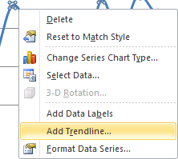
The type of trend line that you choose depends on your data. Linear trends are most common, but some data can be described more effectively with another type.
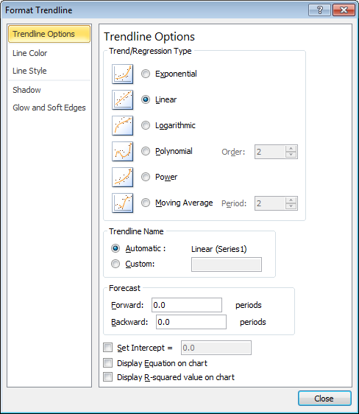
One of the options on the Trendline Options tab is Moving Average, which is useful for smoothing out data that has a lot of variation (that is, "noisy" data). The Moving Average option enables you to specify the number of data points to include in each average. For example, if you select 5, Excel averages every five data points.
The Trendline Options tab enables you to specify a name to appear in the legend and the number of periods that you want to forecast. Additional options let you set the intercept value, specify that the equation used for the trend line should appear on the chart, and choose whether the R-squared value appears on the chart.
Delete a trend line
Click the trend line you want to delete and then press Delete.

How to add error bars in excel
- Open the Excel document in MS Excel 2010, which contains a chart or line chart
- Go to "Chart Tools" menu in the ribbon. Then select "Format" tab first.
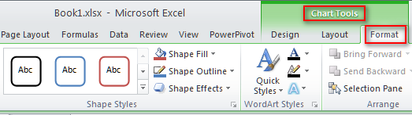
- Under "Format" tab, find "Current Selection" group.
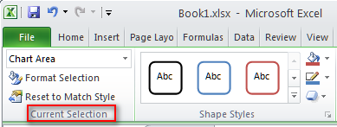
- Then click the arrow to select one element you want, chart area, plot area or others.
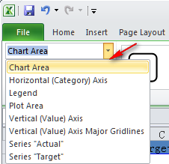
- Then go to "Layout" tab > "Analysis" > "Error Bars".
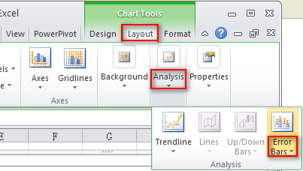
- Click the arrow beside "Error Bars", and choose one type error bar.
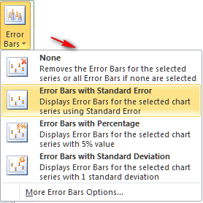

- For example, "Error bars with standard error" has been added in the chart like this.
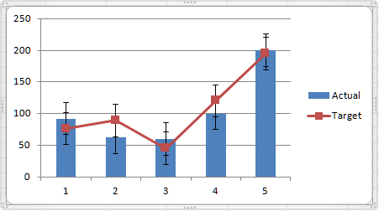
- Next, go to "Format" tab again, and click the arrow in the right corner of "Shape Styles" group.
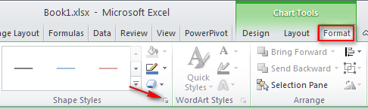
- The "Format Error Bars" window, choose the "display" and "error amount" options that you want to use. Then click "Close".
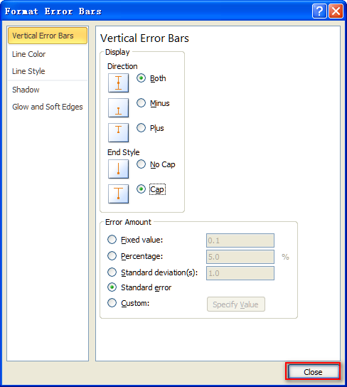
- OK, error bars has been successfully added for the chart.
Tips
What's more, you can remove either of these error bars by selecting them, and then pressing "DELETE" key.

