- Define the following concepts:
- Period

- Ionic bonding

- State which of the following substances have hydrogen bonding: CH₄, HCl, NH₃, LiH.

- Order the following substances in terms of increasing melting points: metallic, simple covalent, giant covalent.

- (Normally formulation) Desribe the 4 quantum numbers and underline which of the following are allowed: (1,0,0,1/2) (3,1,2,-1/2) (2,1,0,1/2) (4,0,-1,1/2)
- Describe how you could distinguish between a simple molecular covalent compound and a giant covalent (lattice) compound.

- In Rutherford’s experiment, most of the alpha particles passed through the gold foil without deflection. However, some of them showed some deflection and a few were even reflected back. Indicate, giving the reasons, how these observations leads to Rutherford’s atomic model.

- State the full exlectron configuration for:
- N (Z=7)

- Zr (Z=40)

- Br- (Z=35)

- Explain, giving reasons, which is the most likely type of bonding found between the following chemical elements (EN = electronegativity):
- Na (EN=0.9) and Cl (EN=3.0)

- Cu (EN=1.9) and Zn (EN=1.6)

- State and explain the trend observed in the boiling points of the following substances (methane, ethane and pentane):

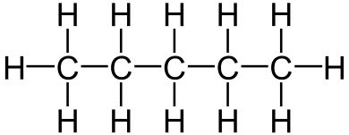
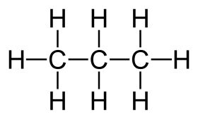
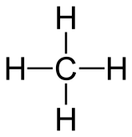

- State and explain how atomic volume (radius) changes down a group and across a period in the periodic table.

- Design a method to distinguish between the four kinds of substances we have studied in the lab based in making tests of its properties.

- Imagine that you are Rutherford making his experiment. You observe that most alpha particles pass through the gold foil but some of them remain inside it. Propose an atomic model according to these observations and explain your reasons for it.

