Unit 1 practice questions
- State the SI units for:
  - Time
  - Length
  - Temperature
  - Light intensity
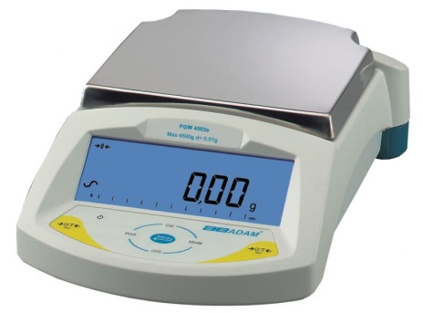
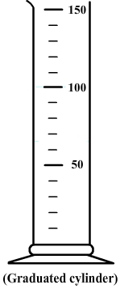
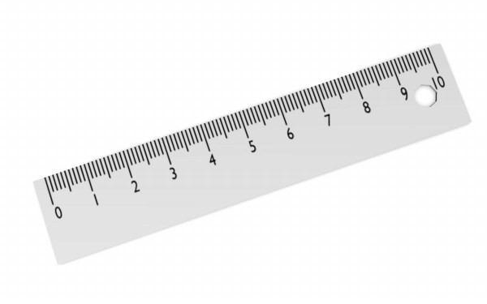
- What is the precision of the following instruments:

- Which type of error could be present when:
  - Digital thermometer
  - Describing the colour of a solution
  - Reading the volume on a measuring cylinder
- Order the following in increasing size:
  - 1 m 200 cm 100 mm 0.01 km
- Name the piece of equipment commonly used when working with the vacuum line.
- How many decimal places (DPs) are in these numbers:
  - 10
  - 27.880
  - 7000000.7
  - 6.30 x 10⁻²
- How many significant figures (SFs) are in these numbers:
  - 250
  - 9
  - 45000.02
  - 4.0010
  - 300450
  - 8.12 x 10⁷
- Convert the following into scientific notation or into a normal number:
  - 4.933 x 10³
  - 5.0 x 10⁻²
  - 9.0111 x 10⁷
  - 981
  - 0.0071
  - 2005600060
- Calculate the following by taking into account the number of DP sor SFs (assume all numbers are data from the lab):
  - 42.0 x 77.822 =
  - $\frac{73.29+6.02+8}{2.874}$=
  - The average of 4.39, 3.98, 4.0, 4.122.
  - $\frac{5.220+(90×301)}{(\frac{73.1}{5.821})×8.522}×(\frac{2.00}{2})$
- How do we reduce the effect of random errors in experiments?
- Convert the following:
  - -12 ºC K
  - 298 K ºC
  - 3400 cm³ dm³
  - 68 dm³ cm³
  - 1520 mmHg atm
  - 3 atm mmHg
  - 16 g oxygen gas moles of oxygen gas
  - 0.01 moles C mass of C

