Transcription an Translation Worksheet

- What are the bases in DNA?

- How do the bases pair up?

- What are the bases in RNA?

What RNA nitrogen bases match with the following DNA nitrogen bases?

A T G C

- If this is a sequence of one DNA strand, what is the complementary sequence of the other DNA strand?

^{5’} A T T C A G C G A ^{3’}

- What in RNA sequence would bond with DNA strand from question 5?

A T T C A G C G A

- Three RNA bases make a……………

- What does a codon code for?

- The shape of a DNA molecule is…………..

- What amino acids are made from these bases? (See chart)

AAC UUC UAA CCG

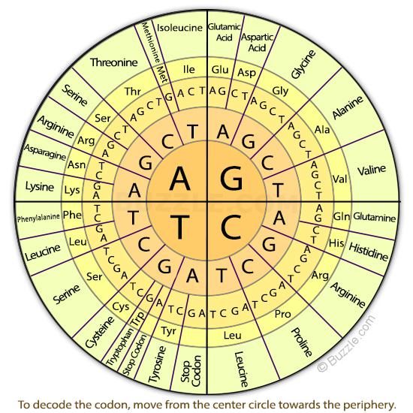

- What do proteins do for us?

- Where are proteins made in the cell (organelle)?

- Imagine you have the following strands of DNA. Go through the process of transcription and translation and build the correct protein.

DNA mRNA Amino Acid

C
A
T

G
G
T

C
A
G

G
C
A

T
A
T

