CHEMISTRY Y10

REDOX REACTIONS. GALVANIC CELLS. ELECTROLYSIS.

- Oxidation state. Concept of redox reaction.

Reactions in Chemistry can be divided, among others, into two large groups:
acid-base (proton transfer) and
redox or reduction-oxidation reactions (electron transfer).

A Redox reaction is defined as that reaction where an electron transfer occurs and at least one element change its oxidation state. In a redox reaction there is always two coupled processes: one oxidation and one reduction:

- Oxidation is the process that involves loss of electrons.

- Reduction is that process that involves gain of electrons.

In a redox reaction, the element which gets oxidized is called reducing agent as it gives electrons to the other, reducing it, and the one that gets reduced, oxidising agent.
Redox couple is the set composed by the oxidized and reduced forms of a determined species.
Eg: Zn²⁺/Zn⁰, Cu²⁺/Cu⁰.

Oxidation state or number of an element is defined as the hypothetical charge an atom would have if all bonds to atoms of different elements were 100% ionic. To determine its value, the following rules are followed:

- The oxidation number of pure elements is zero. Ex.: Fe, P₄ o N₂.

- For simple ions (one single type of atom), the oxidation number equals the charge divided by the number of atoms. Ex: for sulfide ion (S²⁻) the oxidation state of sulfur is –2, and for peroxide (), that of oxygen is –1.

- The oxidation state of H is +1 except for very metallic hydrides (alkalines and alkaline earth elements), which is then –1.

- The oxidation state of O is –2 except for peroxides for which its value is –1.

- In neutral molecules or complex ions, the total sum of all oxidation states of every atom in the molecule has to equal the overall charge (zero for neutral molecules).
For example, in sulfuric acid (H₂SO₄), H has an oxidation state of +1, and it is –2 for O; Deduce the oxidation state of sulfur:

2·(+1)+4·(-2)+n(S) = 0 ⇒ 2-8+n(S) = 0 ⇒ n(S) = +6

Or for nitrosonium ion, NO⁺, O has –2 and therefore N must be +3, so the total charge is +1.

- In the case of organic molecules, we work exactly in the same way, but taking into account that C-C bonds do not affect the oxidation state because electrons are equally distributed.
Important: Remember this is only a method to determine the species that get reduced or oxidised, but organic compounds they are ALWAYS COVALENT!

This way we can assign oxidation states to the structural formula:
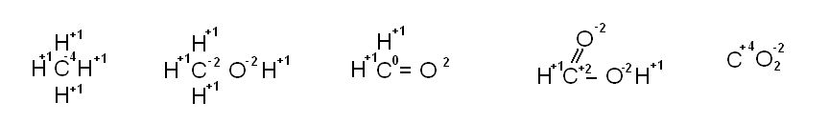
Figure 1. Increasing oxidation states of C, from C⁻⁴ to C⁺⁴.

Redox processes are very common:
rusting of iron bars of a balcony:

cell respiratory processes:

combustion of materials:

Given that in these processes electrons are involved, there is the possibility of use them to obtain an electric current and inversely, generate a redox process by forcing an electric current to pass through.
Find an example where this is used in industry

2. Balancing redox reactions

In order to balance a redox reaction we will use the ion-electron method, which can be divided into a number of steps. We will see them at the same time we balance a typical redox reaction:

HNO₃ + Cu ⎯→ Cu(NO₃)₂ + NO₂

  - If the equation is written in the molecular form we first have to change it to ionic (IMPORTANT: Only ionic compounds!!!). At this point you have to take into account that free elements, oxides, H₂O and NO₂ do not dissociate. Suggest why:

H⁺ + NO₃⁻ + Cu ⎯→ Cu²⁺ + NO₃⁻ + NO₂

  - The half- ionic equations, oxidation and reduction half-reactions, are written.

NO₃⁻ ⎯→ NO₂ REDUCTION
Cu ⎯→ Cu²⁺ OXIDATION

  - Atoms in each half reaction are balanced, according to this sequence:
- Atoms other than O and H
- O atoms, by adding the corresponding number of H₂O molecules
- H atoms, by adding the corresponding number of H⁺ ions

- Balance the charges on opposite sides of each half reaction equation by adding electrons to the appropriate side.

NO₃⁻ + 2 H⁺ + e⁻ ⎯→ NO₂ + H₂O
Cu ⎯→ Cu²⁺ + 2 e⁻

- The number of electrons lost in oxidation must equal the number of electrons gained in the reduction half-reaction. If necessary, multiply each half reaction by the adequate entire number (least common multiple, lcm)

NO₃⁻ + 2 H⁺ + e⁻ ⎯→ NO₂ + H₂O (x2)
Cu ⎯→ Cu²⁺ + 2 e⁻

2 NO₃⁻ + 4 H⁺ + Cu ⎯→ 2 NO₂ + 2 H₂O + Cu²⁺

- Half-reactions are added and common species that appear at both sides of the overall equation are cancelled.

- Check that mass and charge is balanced.

- Balanced Ionic Reaction

- In acidic media, directly go to step 8. If basic media, as many OH- ions are added as H⁺ exist, since H⁺ + OH⁻ --> H₂O. Simplify the reaction as much as possible.

- Add the necessary species to rebuild the initial reagents, and simplify if possible.

2 NO₃⁻ + 4 H⁺ + Cu ⎯→ 2 NO₂ + 2 H₂O + Cu²⁺
2 NO₃⁻ 2 NO₃⁻

4 HNO₃ + Cu ⎯→ 2 NO₂ + 2 H₂O + Cu(NO₃)₂

Balanced Molecular Reaction

Let’s see a second example, corresponding to a redox reaction in basic media, with the additional circumstance that the same substance is oxidized and reduced at the same time; these are called disproportionation or dismutation reactions:

P₄ + KOH ⎯→ KH₂PO₂ + PH₃

P₄ ⎯→ H₂PO₂⁻ OXIDATION
P₄ ⎯→ PH₃ REDUCTION

P₄ + 8 H₂O ⎯→ 4 H₂PO₂⁻ + 8 H⁺ + 4 e⁻ (x3)
P₄ + 12 H⁺ + 12 e⁻ ⎯→ 4 PH₃

4 P₄ + 6 H₂O ⎯→ 3 H₂PO₂⁻ + 3 H⁺ + PH₃
3 K⁺ + 3 OH⁻

P₄ + 3 H₂O + 3 KOH ⎯→ 3 KH₂PO₂ + PH₃

- Galvanic cells or Daniel Cell

One of the more interesting applications of redox reactions is making use of them as source of electrical energy. For this purpose we just have to get the electrons not to transfer directly from one species to the other, but to pass through an external circuit to perform some kind of work. This can be done by physically separating the oxidation and reduction reactions, so that the system can be considered to be formed by two interconnected sub-systems, that we will call half-cells.

A galvanic cell is a system where a redox reaction occurs but where the half-reactions are physically separated and these are only linked through an electrical connection (electrode). Therefore, the electrons from the reducing agent (the one losing the electrons) pass through a circuit where they can perform some electrical work before reaching the oxidising agent (the one gaining the electrons).

The electrode where the oxidation half-reaction takes place is called anode, and the other electrode, where reduction occurs, is called cathode. This is easily remembered if we associate vowels and consonants:

ANODE-OXIDATION CATHODE-REDUCTION.

The following is a scheme of the so called Daniell cell, honouring its discoverer:

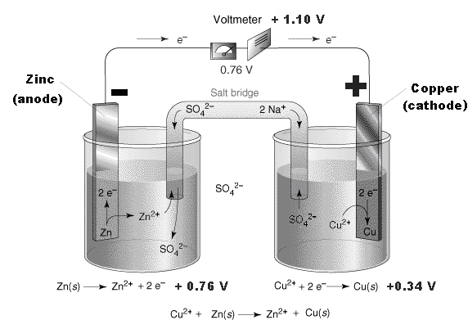

Figure 3. Scheme of a Daniell cell.

Note the direction of movement of electrons Which way do they flow in Galvanic cells?

In the galvanic cells, oxidation reaction takes place in the negative pole. The anode is the electrode with the negative sign. The other electrode, where reduction takes place, is the cathode, the positive electrode.

As you can observe in figure 3, the vessels are connected by a salt bridge. This salt bridge permits interchange of ions between both solutions (no interchange of electrons) so that the electroneutrality of the cell is conserved.
What does electroneutrality mean?

It can be made with a glass U-tube filled with a concentrated salt solution (KCl or KNO3 for example) with both ends closed with cotton, or any semi-permeable membrane which prevents the mixing of solutions while allowing ions to go from one side to the other (as for example, porous plate).

What does semi permeable mean?

Characteristic notation of cells is as follows: electrodes are written on the direction of the reaction, beginning with the anode on the left. The chemical species on each half cell are separated by a slash (/) and the reactions on both half cells are separated by a double slash (//) symbolising the bridge salt:
Zn/Zn²⁺//Cu²⁺/Cu

In this representation electrons move from left to right, just as the direction of writing.
Note that you write red/ox//ox/red

When the concentrations of Zn²⁺ y Cu²⁺ ions are equal to 1 M, the Daniell cell produces a voltage around 1.1 V, and it changes as the concentrations change. It has been experimentally proved that the voltage of a battery depends on a number of factors: temperature, electrodes used and concentrations of all species involved in the redox reaction.

Commercial and industrial systems of electricity production by chemical means have little to do with Daniell cells. One of the more common devices is the dry-cell battery, where the salt bridge is substituted by a porous media (cardboard), and electrolytes are in the form of a moist paste, not dissolved:
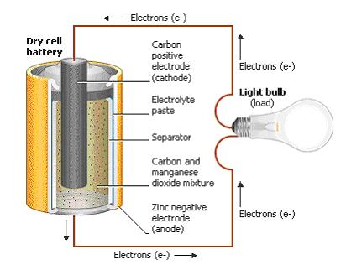
Discharge half-reactions

Zn ⎯→ Zn²⁺+ 2 e⁻

2 NH₄⁺ + 2 MnO₂ + 2 e⁻ ⎯→
⎯→ 2 MnO(OH) + 2 NH₃

Figure 5. Dry cell battery

Lead acid battery
Another extremely important electric system is the lead acid battery, electrical accumulator that is used in motoring, and which can be recharged. So it provides with electricity at the start, and during driving, Using an alternator, the reaction is inversed to produce electricity and it recharges:

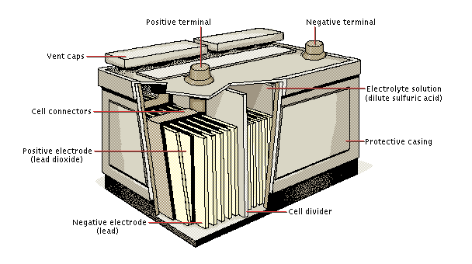
Figure 6. Lead acid battery

Pb + SO₄²⁻ ⇌ PbSO₄ + 2 e⁻

PbO₂ + SO₄²⁻ + 4 H⁺ + 2 e⁻ ⇌
⇌ PbSO₄ + 2 H₂O

4. Electrolysis

Galvanic cells are systems where a redox reaction occurs spontaneously. However, these are not the only interesting redox systems.
Just as a chemical reaction produces electricity the application of electricity can make an interesting chemical reaction work. A redox reaction induced by electricity is called electrolysis or electrolytic process. In this case the reaction is not spontaneous but it has to be externally induced, by applying electrical energy to the system.
In electrolysis, the positive pole is the anode, while the negative one is the cathode, right the opposite of galvanic cells. Each of the vessels where the reaction takes place is called electrochemical cell.
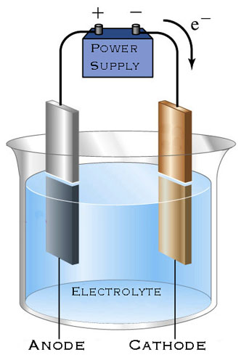
Figure 7. Scheme of an electrochemical cell

Electrolysis was studied by Michael Faraday at the end of the XIX century, and he found that the amount of electricity passing through the system and the effects this produced were quantitatively related. Faraday’s studies can be summarized in two laws:

- Faraday’s 1st law: the mass of a substance deposited by electrolysis is proportional to the amount of electricity that has passed through the electrochemical cell.

where n is the number of electrons exchanged,
M is the molecular mass of the deposited substance (g/mol),
I is the intensity of the current passing through (A),
t is the time the current has been passing through (s) and
F is the Faraday constant, the amount of charge in a mol of electrons, 96 500 C/mol.

- Faraday’s 2nd law: masses of different substances deposited by the same amount of electricity are inversely proportional to the number of electrons exchanged.

where the symbols have the same previous meaning.

Examples of industrial uses of redox reactions

Electrolysis has a lot of important industrial uses, some of which we will see as it follows:

- Decomposing salts: Usually minerals we find in nature have no interest by themselves but just as a source of raw material for any of the elements in its composition; one of the various ways to obtain one of these elements which compose salt is dissolving or melting the solid and then performing an electrolysis on it. It can be observed the scheme of the electrolysis of molten sodium chloride (not dissolved); gaseous chlorine and metallic sodium are obtained, both important raw materials for chemistry industry. The occurring reactions are:

Na⁺ + e⁻ ⎯→ Na REDUCTION, CATHODE
2 Cl⁻ ⎯→ Cl₂ + 2 e⁻ OXIDATION, ANODE

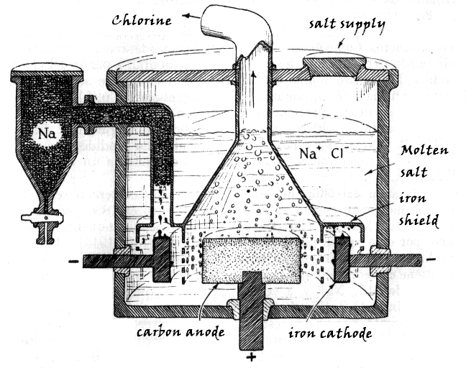

Figure 8. Chlorine and sodium are obtained from molten NaCl salt, by electrolysis.
General Chemistry, L. Pauling.

- Obtention of metals is a very similar process to the previous one. Among all possible processes, the most important one is by far the extraction of aluminium. So much that all the commercial aluminium in the world is obtained by electrochemical procedures. Alumina, Al₂O₃, (previously purified from bauxite) is dissolved in a carbon-coated iron bath of molten cryolite, Na₃AlF₆, to reduce the melting point of the alumina. The mixture is electrolyzed, reducing the oxide to liquid aluminium and depositing as a precipitate. The carbon anode is oxidized and bubbles away as carbon dioxide. The resistance to the passing current provides the adequate temperature to keep the electrolyte molten (1000 °C). The occurring processes are:

Al³⁺ + 3 e⁻ ⎯→ Al
2 O²⁻ + C ⎯→ CO₂ + 4 e⁻

The reaction runs with a difference of potential of 5 V. The carbon anodes are consumed and must be continuously replaced. Aluminium is “bled” from the bottom of the bath, where it accumulates due to its higher density.

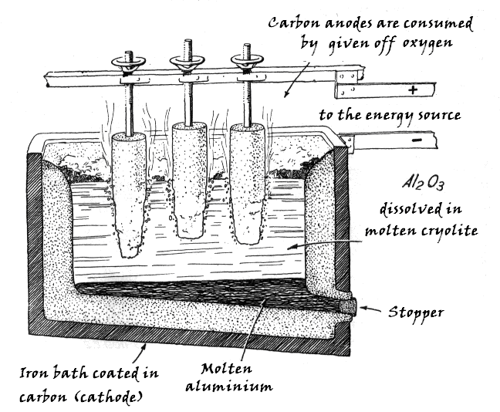

Figure 9. Electrolytical reduction for aluminium extraction, according to Hall-Heroult process.
General Chemistry, L. Pauling

- Electrochemical refining: Electrochemical reduction is a purifying procedure for metals. It involves the dissolution of raw metallic anodes and deposition on pure cathodes. In this process impurities do not dissolve, and either precipitate or they remain at the anode. The following example corresponds to the electrochemical refining of copper:

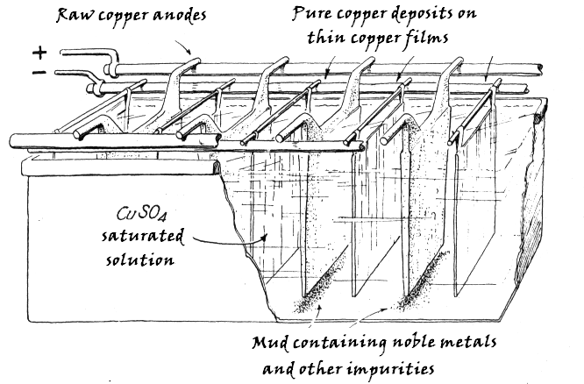

Figure 10. Electrochemical refining of copper. General Chemistry, L. Pauling.

- Other uses: not least important are the electrochemical deposition of metals films, and the electromachining or electroforming of metallic pieces.

Questions and problems

- Calculate the oxidation state of each of the following chemical species: a) NO₂, b) H₅IO₆, c) O₃, d) O₂, e) O₂²⁻, f) (NH₄)₂Cr₂O₇, g) NO⁺, h) PCl₃, i) C₆H₆, j) CH₂=CH₂, k) NaHCO₃, l) Fe³⁺, m) Ne, n) Sc₂O₃, o) OsO₄, p) H₂O₂, q) PdH₄, r) P₄, s) AsH₃, t) P₂O₅⁴⁻, u) NH₄⁺, v) SnI₄, w) ICl₄⁻ y x) K₂O₂.
- Balance the following redox reactions:
- HCl + KMnO₄ ⎯⎯⎯→ Cl₂ + KCl + MnCl₂ + H₂O
- FeSO₄ + KMnO₄ + H₂SO₄ ⎯⎯⎯→ Fe₂(SO₄)₃ + MnSO₄ + K₂SO₄ + H₂O
- Cu + HNO₃ ⎯⎯⎯→ NO + Cu(NO₃)₂ + H₂O
- Zn + HNO₃ ⎯⎯⎯→ Zn(NO₃)₂ + (NH₄)NO₃ + H₂O
- FeCl₂ + H₂O₂ + HCl ⎯⎯⎯→ FeCl₃ + H₂O
- KMnO₄ + H₂O₂ + H₂SO₄ ⎯⎯⎯→ MnSO₄ + O₂ + K₂SO₄ + H₂O
- KMnO₄ + SnCl₂ + HCl ⎯⎯⎯→ MnCl₂ + SnCl₄ + KCl + H₂O
- FeSO₄ + K₂Cr₂O₇ + H₂SO₄ ⎯⎯→ Cr₂(SO₄)₃ + Fe₂(SO₄)₃ + K₂SO₄ + H₂O
- Na₂SO₃ + NaMnO₄ + HCl ⎯⎯⎯→ Na₂SO₄ + MnCl₂ + H₂O + NaCl
- O₂ + H₂S ⎯⎯⎯→ S + H₂O
- MnO₂ + O₂ + KOH ⎯⎯⎯→ K₂MnO₄ + H₂O
- SO₂ + HNO₃ + H₂O ⎯⎯⎯→ H₂SO₄ + NO
- Zn + NaNO₃ + NaOH ⎯⎯⎯→ Na₂ZnO₂ + NH₃ + H₂O
- KI + KClO₃ + H₂O ⎯⎯⎯→ I₂ + KCl + KOH
- Al + NaNO₃ + NaOH ⎯⎯⎯→ Na[Al(OH)₄] + NH₃
- KMnO₄ + K₂S₂O₃ + HCl ⎯⎯⎯→ K₂SO₄ + MnCl₂ + MnSO₄ + H₂O
- NaClO₃ + Cr(NO₃)₃ + NaOH ⎯⎯⎯→ NaCl + Na₂CrO₄ + H₂O + NaNO₃
- CH₃CH₂OH + H₂O₂ ⎯⎯⎯→ CH₃CHO + H₂O
- HOOC-COOH + KMnO₄ + HCl ⎯⎯⎯→ CO₂ + MnCl₂ + H₂O + KCl
- CH₃CHO + K₂Cr₂O₇ + H₂SO₄ ⎯⎯⎯→ CH₃COOH + Cr₂(SO₄)₃ + H₂O + K₂SO₄
- K₂Cr₂O₇ + SnO + HCl ⎯⎯⎯→ SnCl₄ + CrCl₃
- NaClO + NaI + HCl ⎯⎯⎯→ I₂ + NaCl
- HNO₃ + H₂S ⎯⎯⎯→ NO + S
- NaClO + Fe(OH)₃ + NaOH ⎯⎯⎯→ NaCl + Na₂[FeO₄] + H₂O
- KMnO₄ + KCI + H₂SO₄ ⎯⎯⎯→ MnSO₄ + CI₂ + K₂SO₄ + H₂O
- HNO₃ + Fe ⎯⎯⎯→ Fe(NO₃)₃ + NO + H₂O
- Given the chemical reaction: potassium dichromate + hydroiodic acid + perchloric acid, yielding to chromic perchlorate + molecular iodine + potassium perchlorate + water: a) balance the reaction; b) determine which is the oxidant specie; c) calculate the number of grams of iodine obtained in the reaction if 200 cc of 2 M solution of the oxidant are consumed. Cr 52; K 39; I 127.
- Potassium permanganate react with hydrogen sulfide in presence of manganese(II) sulfate, sulfur, potassium sulfate and water: a) balance the corresponding redox equation; b) indicate which is the reductant specie and the anode; c) determine the volume of 0.5 M hydrogen sulfide solution needed if in the process 100 g of sulfur are obtained. S 32, K 39.

- Manganese dioxide and potassium iodide react in presence of sulfuric acid to give manganese(II) sulfate, iodine, potassium sulfate and water: a) balance the given reaction; b) determine the oxidant and the reductant species; c) calculate the maximum number of grams of iodine possible, if we begin with 1 kg de manganese dioxide 95.7 % in richness. Mn 55, K 39; I 127.
- Nitric acid attacks mercury in presence of hydrochloric acid to give nitrogen, mercury chloride and water: a) balance the corresponding redox reaction; b) determine which is the reductant specie and the cathode; c) determine how many litres of water vapour will be given off at 127 °C and 1520 mmHg, it 500 cc of 2 M nitric acid solution are consumed in the process. N 14, Hg 200
- What electrical current should pass through a ferric nitrate solution if 28 g of iron are to be deposited in 6 hours? What if we had cupric instead of ferric nitrate?

- An electrolysis has taken place for 48 minutes and 15 seconds using a 0.5 A current on 1 L of 0.5 M cobalt(III) chloride solution. How much cobalt will be deposited? What will be the cobalt concentration after this procedure has taken place?

- How long will it take to deposit all the silver contained in a 100 mL beaker full of 0.1 M silver nitrate using a 0.1 A current? With the same intensity and time, how much gold from a gold chloride solution could be deposited?

- Without performing any calculation, answer these questions: what element will deposit a higher number of moles for the same intensity and time, copper from copper sulfate or aluminium from aluminium oxide? In order to obtain the same number of moles of copper and aluminium at the time, should I increase or reduce the current through the copper solution?
Solutions:
- a) N⁺⁴, O⁻²; b)H⁺¹, I⁺⁵, O⁻²; c) O⁰; cd) O⁰; e) O⁻¹; f) N⁻³, H⁺¹, Cr⁺⁶, O⁻²; g)N⁺³, O⁻²; h)P⁺³, Cl⁻¹; i) C⁺¹, H⁻¹; j) C⁺², H⁻¹; k) Na⁺¹, H⁺¹, C⁺⁴, O⁻²; l) Fe⁺³, m) Ne⁰; n) Sc⁺³, O⁻²; o) Os⁺⁸, O⁻²; p) H⁺¹, O⁻¹; q) Pd⁺⁴, H⁻¹; r) P⁰; s) As⁺³, H⁻¹; t) P⁺³, O⁻²; u) N⁻³, H⁺¹; v) Sn⁺⁴, I⁻¹; w) I⁺³, Cl⁻¹; x) K⁺¹, O⁻¹

- 16 HCl + 2 KMnO₄ ⎯⎯⎯→ 5 Cl₂ + 2 KCl + 2 MnCl₂ + 8 H₂O
- 10 FeSO₄ + 2 KMnO₄ + 8 H₂SO₄ ⎯⎯⎯→ 5 Fe₂(SO₄)₃ + 2 MnSO₄ + K₂SO₄ + 8 H₂O
- 3 Cu + 8 HNO₃ ⎯⎯⎯→ 2 NO + 3 Cu(NO₃)₂ + 4 H₂O
- 3 Zn + 10 HNO₃ ⎯⎯⎯→ 4 Zn(NO₃)₂ + (NH₄)NO₃ + 3 H₂O
- 2 FeCl₂ + H₂O₂ + 2 HCl ⎯⎯⎯→ 2 FeCl₃ + 2 H₂O
- 2 KMnO₄ + 5 H₂O₂ + 3 H₂SO₄ ⎯⎯⎯→ 2 MnSO₄ + 5 O₂ + K₂SO₄ + 8 H₂O
- 2 KMnO₄ + 5 SnCl₂ + 16 HCl ⎯⎯⎯→ 2 MnCl₂ + 5 SnCl₄ + 2 KCl + 8 H₂O
- 6 FeSO₄ + K₂Cr₂O₇ + 7 H₂SO₄ ⎯⎯→ Cr₂(SO₄)₃ + 3 Fe₂(SO₄)₃ + K₂SO₄ + 7 H₂O
- 5 Na₂SO₃ + 2 NaMnO₄ + 6 HCl ⎯⎯⎯→ 5 Na₂SO₄ + MnCl₂ + 3 H₂O + 2 NaCl
- O₂ + 2 H₂S ⎯⎯⎯→ 2 S + 2 H₂O
- 2 MnO₂ + O₂ + 4 KOH ⎯⎯⎯→2 K₂MnO₄ + 2 H₂O
- 3 SO₂ + 2 HNO₃ + 2 H₂O ⎯⎯⎯→ 3 H₂SO₄ + 2 NO
- 4 Zn + NaNO₃ + 7 NaOH ⎯⎯⎯→ 4 Na₂ZnO₂ + NH₃ + 2 H₂O
- 6 KI + KClO₃ + 3 H₂O ⎯⎯⎯→ 3 I₂ + KCl + 6 KOH
- 8 Al + 3 NaNO₃ + 5 NaOH + 18 H₂O ⎯⎯⎯→ 8 Na[Al(OH)₄] + 3 NH₃
- 8 KMnO₄ + 5 K₂S₂O₃ + 14 HCl ⎯⎯⎯→ 9 K₂SO₄ + 7 MnCl₂ + MnSO₄ + 7 H₂O
- NaClO₃ + 2 Cr(NO₃)₃ + 10 NaOH ⎯⎯⎯→ NaCl + 2 Na₂CrO₄ + 5 H₂O + 6 NaNO₃
- CH₃CH₂OH + H₂O₂ ⎯⎯⎯→ CH₃CHO + 2 H₂O
- 5 HOOC-COOH + 2 KMnO₄ + 6 HCl ⎯⎯⎯→ 10 CO₂ + 2 MnCl₂ + 8 H₂O + 2 KCl
- 3 CH₃CHO + K₂Cr₂O₇ + 4 H₂SO₄ ⎯⎯→ 3 CH₃COOH + Cr₂(SO₄)₃ + 4 H₂O + K₂SO₄
- K₂Cr₂O₇ + 3 SnO + 20 HCl ⎯⎯⎯→ 3 SnCl₄ + 2 CrCl₃ + 10 H₂O + 2 KCl
- NaClO + 2 NaI + 2 HCl ⎯⎯⎯→ I₂ + 2 NaCl
- 2 HNO₃ + 3 H₂S ⎯⎯⎯→ 2 NO + 3 S + 4 H₂O
- 3 NaClO + 2 Fe(OH)₃ + 4 NaOH ⎯⎯⎯→ 3 NaCl + 2 Na₂[FeO₄] + 5 H₂O
- 2 KMnO₄ + 10 KCI + 8 H₂SO₄ ⎯⎯⎯→ 2 MnSO₄ + 5 CI₂ + 6 K₂SO₄ + 8 H₂O
- 4 HNO₃ + Fe ⎯⎯⎯→ Fe(NO₃)₃ + NO + 2 H₂O

- a) K₂Cr₂O₇ + 6 HI + 8 HClO₄ ⎯⎯→ 2 Cr(ClO₄)₃ + 3 I₂ + 2 K₂SO₄ + 7 H₂O
b) Cr₂O₇⁼, c) 304.8 g I₂

- a) 2 KMnO₄ + 5 H₂S + 3 H₂SO₄ ⎯⎯⎯→ 2 MnSO₄ + 5 S + K₂SO₄ + 8 H₂O
b) MnO₄⁻, c) 6.25 L

- a) MnO₂ + 2 KI + 2 H₂SO₄ ⎯⎯⎯→ MnSO₄+ K₂SO₄ + I₂ + 2 H₂O
b) MnO₂ (oxidant), I⁻ (reductant), c) 2794 g

- a) 2 HNO₃ + Hg + 2 HCl ⎯⎯⎯→ 2 NO₂ + HgCl₂ + 2 H₂O
b) Hg, c) 16.4 L

- a) 0.67 A, b) 4 h

- a) 5x10⁻³ mol, b) 0.4995 M

- a) 9650 s or 2h 40’ 50”, b) A third, 3.33x10⁻³ mol

- a) Higher number for Cu than for Al, at a rate of 3/2, b) it should decrease.

