3rd term topics practice exam
- State the definition of oxidation and reduction.Ox-Loss of electrons; Red-Gain of electrons
- State the oxidation numbers on the following species: H+1 N+5 O-2 , Mn+6 O-2 , O 0.
- Sketch a position-time graph for a stationary flat line a position 0, URM straight line increasing in position and UARM exponentially increasing line body.
- A bank robber passes a police patrol car at a constant velocity 72 km/h. The patrol car sets off immediately with an acceleration of 3 m/s². Calculate how long will it take to catch up with the bank robber? Sf=So+(v·t) and Sf=So*(vo·t)+0.5·a·t²; Sf1=Sf2; t=13.3 m;
- Convert the following units: 100000 N/m² N/mm²=0.1 N/mm2 40 m/s km/h =144 km/h, 20000 cm³ m³=0.02 m3
- The following graph shows a velocity-time graph for a journey. State the 3 parts of the journey that show an acceleration. State which part is the fastest acceleration and calculate the value for it. 0A, BC, DE; BC is fastest; -3.33 m/s2
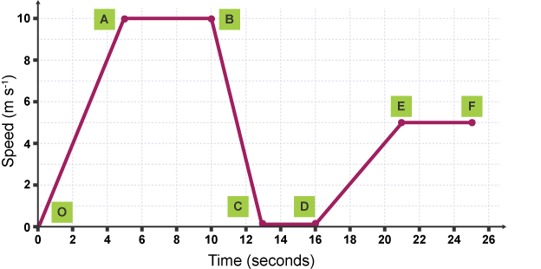
- Label friction, normal and gravity forces on this diagram.
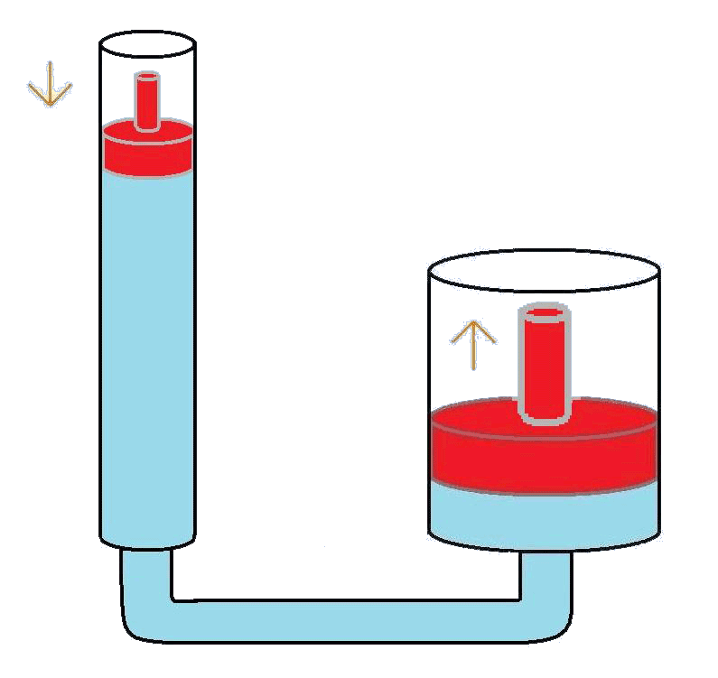
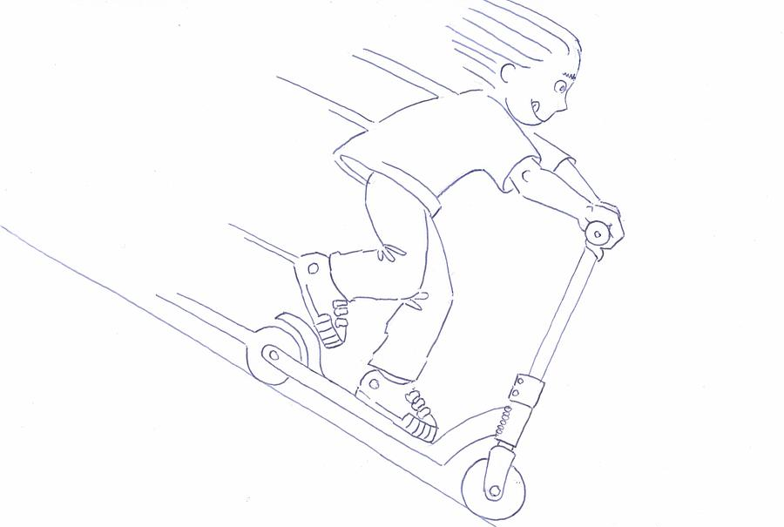
- The surface area of the piston on the left, A_{left}, is 0.1 m² and an object of mass, 100 kg is place on top. If an object of mass of 400 kg is placed on the piston on the right, calculate the minimum surface area required for A₂, if the object is to be lifted. F1/A1=F2/A2; F1=980 N and F2 = 3920 N; A2=0.4 m2

- A submarine is built to withstand 3028200 Pa. Calculate the maximum depth that it could go under the surface of the ocean. Data: d_{sea water}=1.03 g/cm³. P=hdg; h=P/dg; h=300 m
- After playing on a trampoline a young child touches the metal rim and receives an electric shock. Explain, in terms of static electricity, what happened. Rubbing between the child and the trampoline caused a build of of positive or negative charge on the child, when they touched the metal rim elec trons jumped from one to the other to balance the charge difference, this movement of electrons is the electric shock.
- A pile of forty 2 kg bricks was lifted by a crane from the 3rd storey of a building to the 8th storey. Calculate the increase in gravitational potential energy. Data: Height of each storey = 3 m. PE=mgh; Change in h=5*3=15 m; PE=80kg·9,8·15m=11760 J
- The use of biomass (plants grown to burn as fuels) is one example of a renewable energy source. Explain why it is considered “renewable” and explain 2 negative consequences of its use as a fuel. Plants can be continually regrown; burning plants still releases greenhouse gas CO2 (contributes to global warming); we must use food sources as a fuel which may affect food markets.

