*6977353268*
Cambridge International Examinations
Cambridge International General Certificate of Secondary Education

BIOLOGY 0610/21

Paper 2 Multiple Choice (Extended) October/November 2017

45 minutes

Additional Materials: Multiple Choice Answer Sheet
Soft clean eraser
Soft pencil (type B or HB is recommended)

1 Which term is defined as all the chemical reactions that occur in cells?

A photosynthesis

B protein synthesis

C respiration

D metabolism

2 The diagram shows a section of DNA from a chimpanzee.

A G C T A C A G A G

Which diagram shows a section of DNA from the organism that is most closely related to the chimpanzee?

A A G C T A C A G A T

B A G C T A C A G T T

C A T C A A C A G T T

D A T C T A C A G T T

3

4 The diagrams show a leaf and its internal structure.

2

1

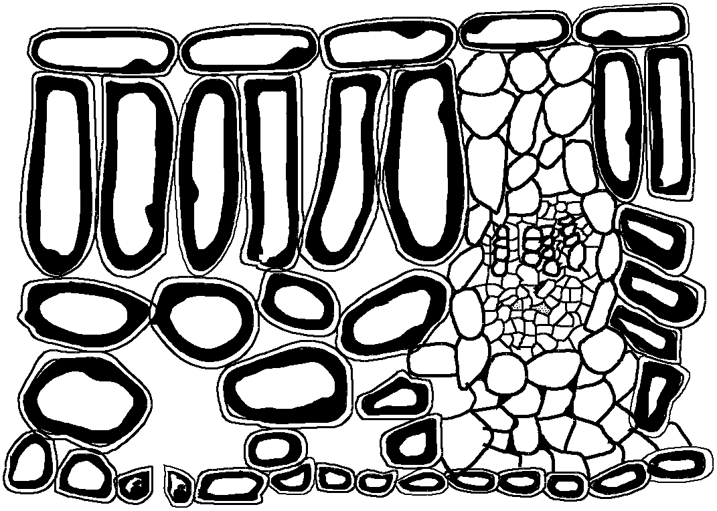3

What are the levels of organisation of the labelled structures?

1 2 3

A cell tissue organ system

B organ cell tissue

C organ system tissue cell

D tissue cell organ

5 Different factors affect the rate of diffusion of molecules across a membrane.

Which row represents changes to factors that will increase the rate of diffusion?

concentration gradient across a membrane

thickness
of membrane

surface area
of membrane temperature

A decrease decrease increase increase B decrease increase increase decrease C increase decrease increase increase D increase increase decrease decrease

6
7 The diagram shows a protease molecule catalysing the break down of a protein molecule.

P

Q

R

S

What are the parts labelled P, Q, R and S?

enzyme product substrate active site

A P Q R S B R S P Q C S P Q R D S R Q P

8 The diagram shows the structure of part of a DNA molecule.

X

What does X represent?

A amino acid

B base

C carbon

D protein

9 Which statement about enzymes is correct?

A Enzymes become part of the product.

B Lowering the pH always slows down the reaction rate.

C Raising the temperature always increases the reaction rate.

D The specificity of an enzyme depends on the shape of its active site.

10
11 Which structure would be found in large numbers in cells that have a high energy requirement?

A chloroplast

B endoplasmic reticulum

C large vacuole

D mitochondrion

12 What must be increased in the diet of a person suffering from constipation?

A fats B fibre C iron
D protein

13 Which disease can be caused by a deficiency of iron in the diet?

A anaemia

B kwashiorkor

C marasmus

D rickets

14 The diagram shows the human alimentary canal, with a string marked in metres beside it.

0 oesophagus

1

2

3

string marked in metres
4

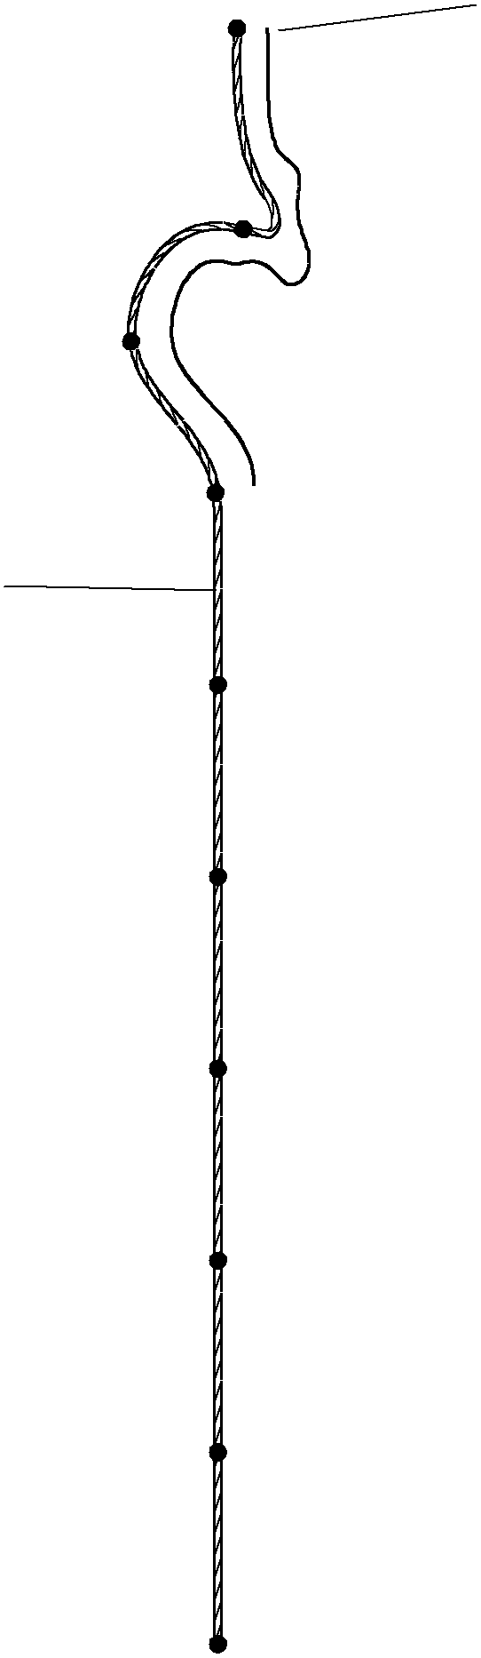5

6

7

8

9

How long is the small intestine?

anus

A 2 m B 6 m C 8 m D 9 m

18 The diagram shows a cross-section through a human blood vessel.

elastic and fibrous connective tissue

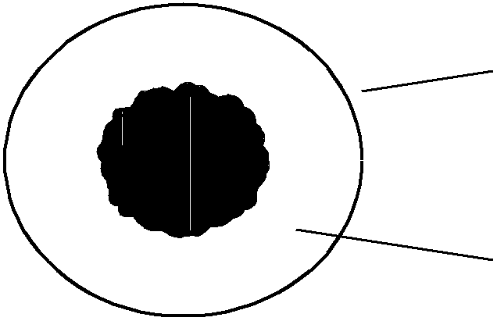muscle layer

Which type of blood vessel does the diagram show?

A an artery

B a capillary

C a vein

D a ventricle

19 Which are both chemical barriers to the transmission of pathogens?

A mucus and stomach acid

B mucus and white blood cells

C skin and hairs in the nose

D skin and stomach acid

20 The table shows some of the changes that occur during breathing.

from contracted to relaxed
from relaxed to contracted

diaphragm P X

external intercostals Q Y

internal intercostals R Z

Which changes occur to cause inspiration?

A P, Q and Z B X, Q and R C X, Y and R D X, Y and Z

23 What is the most important function of sweating?

A to remove excess heat from the body
B to remove excess salts from the body
C to remove excess urea from the body
D to remove excess water from the body

24 Four effects of a specific hormone are listed.

● increased blood pressure

● increased blood glucose concentration

● increased rate of respiration

● reduced blood flow to the gut

What is this hormone?

A adrenaline

B glucagon

C insulin

D testosterone

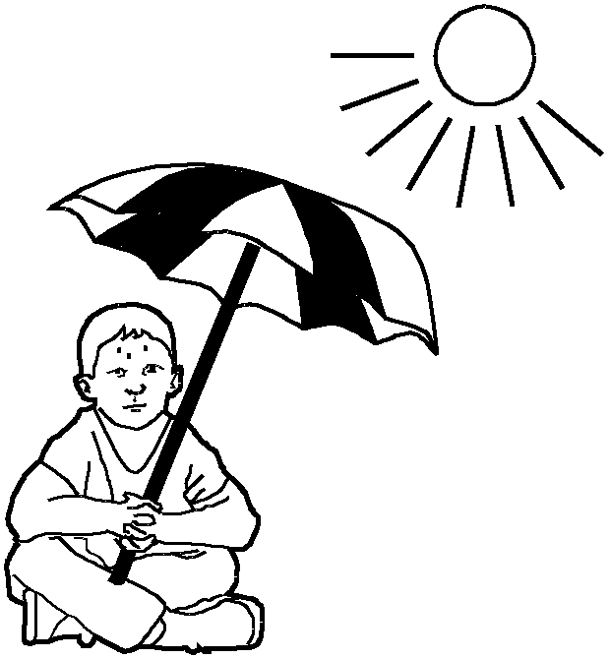25 The diagram shows a person sweating in hot weather.

What part is played by sweat glands during the process of sweating?

A effector

B receptor

C sense organ

D stimulus

27 The immune system recognises pathogens and attacks them.

Which feature of pathogens triggers this response?

A antibodies B antibiotics C antigens
D memory cells

28 Which environmental factor is not always a requirement for seed germination?

A light

B oxygen

C suitable temperature

D water

30 In some mammals the allele for brown coat colour is dominant to the allele for white coat colour.

Which percentage of offspring will be white if a cross is made between two heterozygous mammals?

A 0% B 25% C 50% D 100%

31 Which term is defined as a length of DNA that codes for a protein?

A amino acid

B chromosome

C gene

D mutation

32 The following are involved in protein synthesis.

1 amino acids assembled in order

2 mRNA moves to the cytoplasm

3 mRNA passing through a ribosome

4 DNA in the nucleus

In which order do they become involved when proteins are made?

A 1 → 3 → 2 → 4

B 3 → 2 → 1 → 4

C 4 → 2 → 3 → 1

D 4 → 3 → 2 → 1

34 The distribution of the sickle-cell allele in human populations varies in different areas of the world.

What is an explanation for this difference?

A People that are heterozygous for the sickle-cell allele have a resistance to cholera.

B People that are heterozygous for the sickle-cell allele have a resistance to malaria.

C People that are heterozygous for the sickle-cell allele are more likely to suffer from anaemia.

D People with sickle-cell anaemia have more alleles.

38 Ligase enzymes are used in genetic engineering to

A cut open plasmid DNA.

B insert plasmids into bacteria.

C isolate the DNA making up a human gene.

D join human DNA to plasmid DNA

