Session 6: | TESTINg FOR BIOMOLECULES

Assessed criteria
Criterion E: AIE

Task:
To determine the presence of different biomolecules by using specific biochemical assays.

Background:
If a substance loses electrons during a reaction, it has been oxidized.
If it gains electrons, it has been reduced.
A) Presence of reducing monosaccharides: Fehling
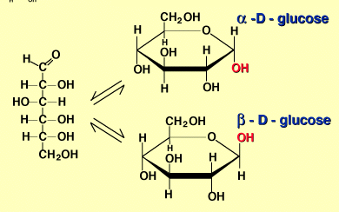
Monosaccharides and the majority of disaccharides (with the exception of sucrose) have a ‘reducing power’ as they have a carbonyl group(C=O) which can be oxidized into a carboxyl group (acid -COOH), as the other compound is reduced. We can see how this reaction takes place by using Fehling reagent, where a blue-coloured copper sulphate solution (Fehling reagent) is transformed to cuprous oxide, brick red-coloured (this reaction is favoured in an alkaline environment and applying heat)
CuSO
4
Cu(OH) (blue)
2
CuO (red brick)
2
NaOH
+Heat
+R
The colour change tells us that the redox (oxidation-reduction) reaction has taken place, and therefore the glucid being analysed is the reducing agent, as it has been oxidized (it is losing electrons)
B) Presence of starch: Lugol
Starch is a polysaccharide found in plants. It is a polysaccharide made of many monosaccharides bonded by a O-glucosidic bond. This bond takes place between the hydroxyl (-OH) groups of two monosaccharides, making a disaccharide and a water molecule. Starch does not have a 'reducing power', since it does not have a free carboxyl group to be oxidized (giving a negative result for the Fehling reaction).
In order to test the presence of starch an iodine/potassium iodide solution known as Lugol is used. Lugol will stain deep blue-black coloured the starch present in a sample. This staining is not the result of a chemical reaction, but the result of the absorption of the iodine on the surface of the starch molecule (will only happen at room temperature).
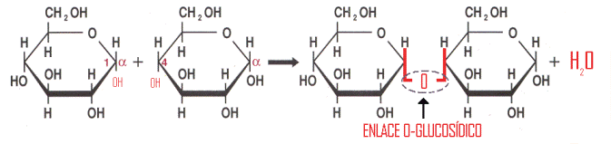

C) Presence of proteins: Biuret

Biuret reagent is often used to determine the presence of proteins. The reaction that takes place is specific for proteins but not for amino acids (the building blocks of proteins) as it is due to the peptide bond. A peptide bond is a chemical bond that is formed between two molecules when the carboxyl group of one molecule reacts with the amino group of the other molecule, releasing a molecule of water.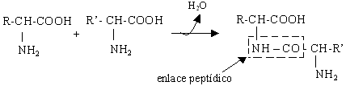
When a protein comes in contact with a concentrated alkaline a complex substance known as Biuret is formed, which in contact with a diluted cupric sulphate solution gives a characteristic violet coloured solution that identifies the presence of proteins.
D) Presence of lipids: Sudan III
Lipids are organic biomolecules with long hydrocarbonated chains, which make them insoluble in polar substances (such as water) since they cannot make hydrogen bonds with the molecules of the solvent.
Lipids can be tested using Sudan III reagent, as they are stained in a characteristic red colour.

Complete the following table:

Name of test: | Tests for presence of: | Reagents used: | Colour change:

Materials:
- NaOH 10% - Fehling A and B reagent - Lugol reagent (K + KI)
- Pipettes and bulb - Cupric sulphate 1% - Test tubes
- Bunsen burner - Starch solution 0.5% - Glucose solution 0.5 %
- Egg white - Oil - Dropper
- Sudan III reagent - Amino acids solution at 1%

Procedure:
Testing for reducing glucids
- Take 7 test tubes and a test tube rack and number them (1-7)
- Add 2 mL of starch to test tubes 1 and 2.
- Add 2 mL of glucose to test tubes 3 and 4.
- Add 2 drops of Lugol reagent to test tubes 1 and 3. Write down the results.
- Add 0.5 mL of Fehling A and 0.5 mL of Fehling B reagents to test tubes 2 and 4. Heat them up gentle with a warm water bath and write down the results.
Testing for proteins.
- Add 2 mL of egg white to test tube # 5 and 2 mL of the amino acids solution to test tube # 6.
- Add to both test tubes 0.5 mL of NaOH 10%.
- Add to both test tubes a few drops of cupric sulphate 1%. Write down the results.
Testing for lipids.
- Add 2 mL of oil and 2mL of water to test tube # 7
- Add a few drops of Sudan III reagent. Write down the results.
Results:
Make a neat, clear and orderly presented table with all your results, and add a picture of your test tubes to this document, substituting the one here below.
. 