Introduction to the heart

Task 1
1.1
Use BioDigital Human (LINK) to explore the heart. Use the scalpel function to take some parts away if needed

Locate:
- Aorta
- Pulmonary artery
- Pulmonary vein
- Vena Cava
- Right atrium
- Right ventricle
- Left atrium
- Left Ventricle
- Tricuspid valves
- Bicuspid valves

1.2
Label the parts from above in this diagram:
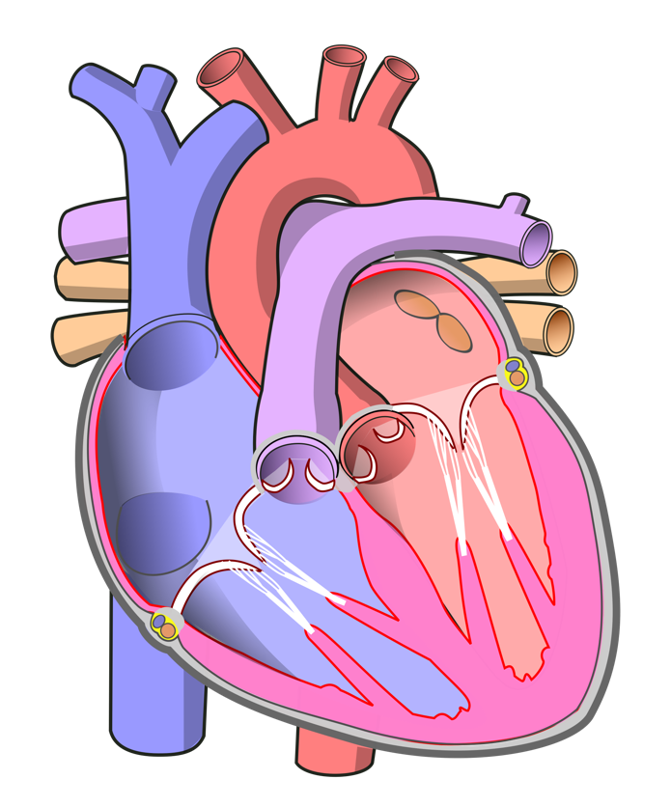

1.3
Put the parts from 1.1 in order according to the blood flow through the heart. From where it enters until where it leaves it.

1:
2:
3:
4:
5:
6:
7:
8:
9:
10:

Task 2
2.1
Measure your heart rate (BPM) at this moment and compare it to the average heartrate of people of your age (do some research).

BPM now:
Average BPM:
Conclusion:

2.2
Measure your blood pressure and add the systolic and diastolic pressure here below. Compare it to the average pressure of people of your age (do some research).

Systolic pressure now:
Diastolic pressure now:
Average systolic pressure:
Average diastolic pressure:
Conclusion:

Task 3
Design a plan for the coming week to measure your heartrate (BPM) in 5 different situations. (sports, exiting movie, exiting event, rest, morning, night, coffee….). Prepare a short explanation for next week’s class on this.

