PP.

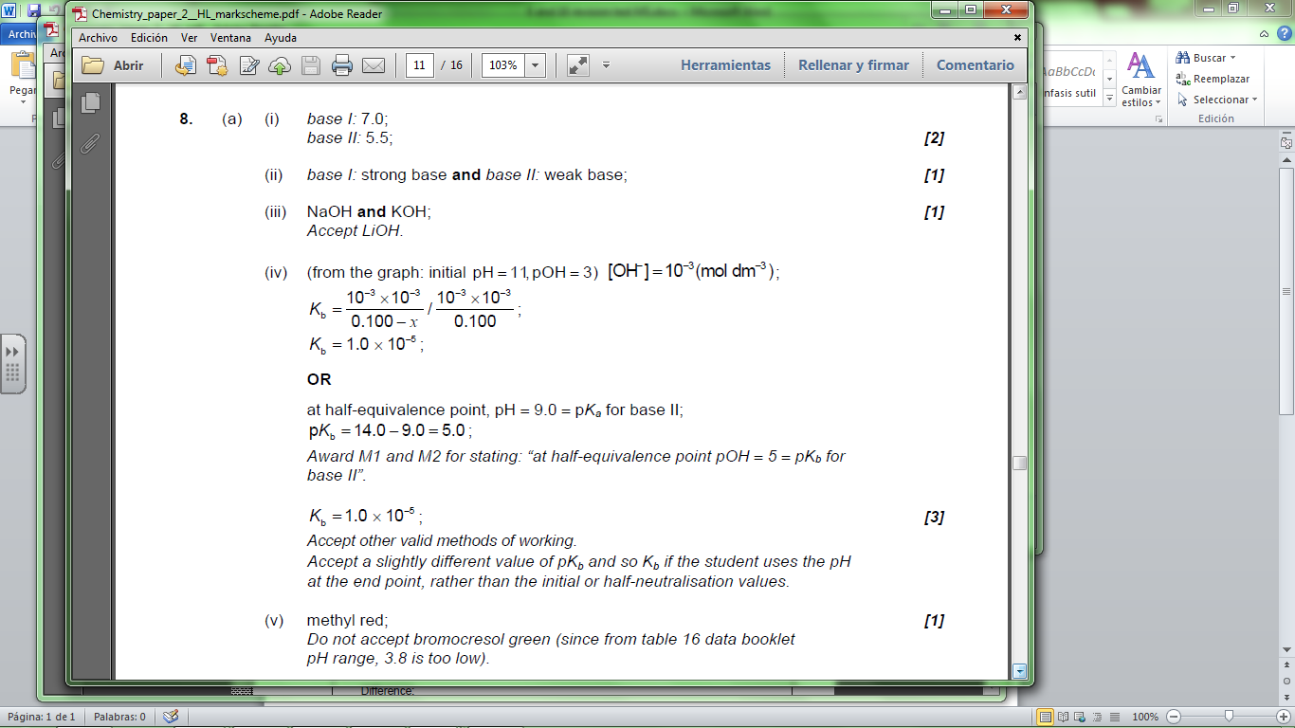

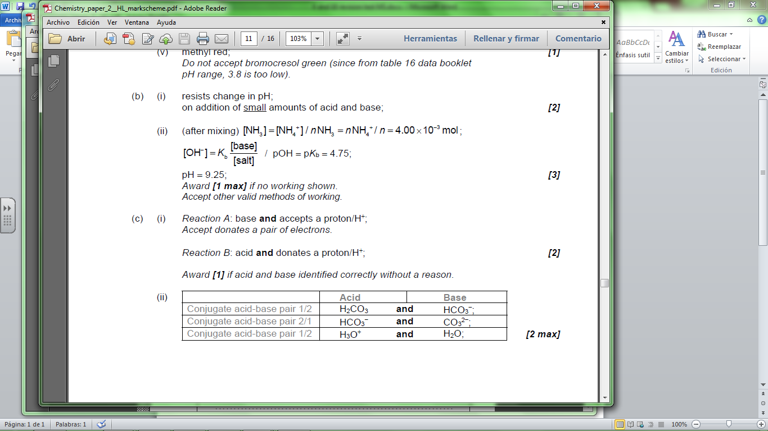

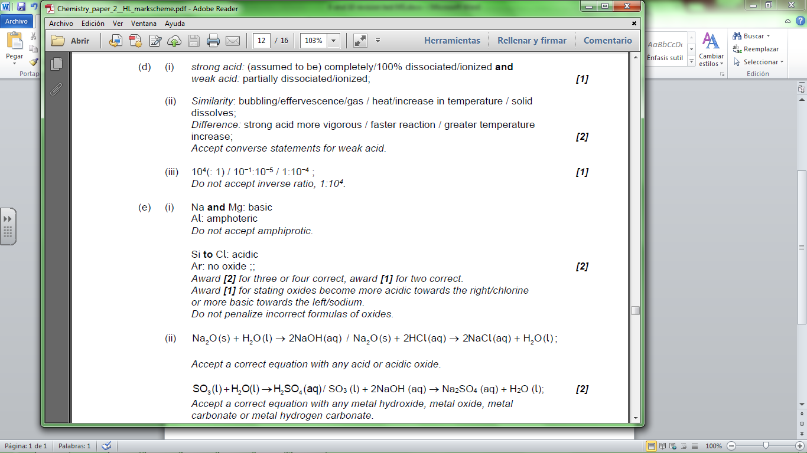

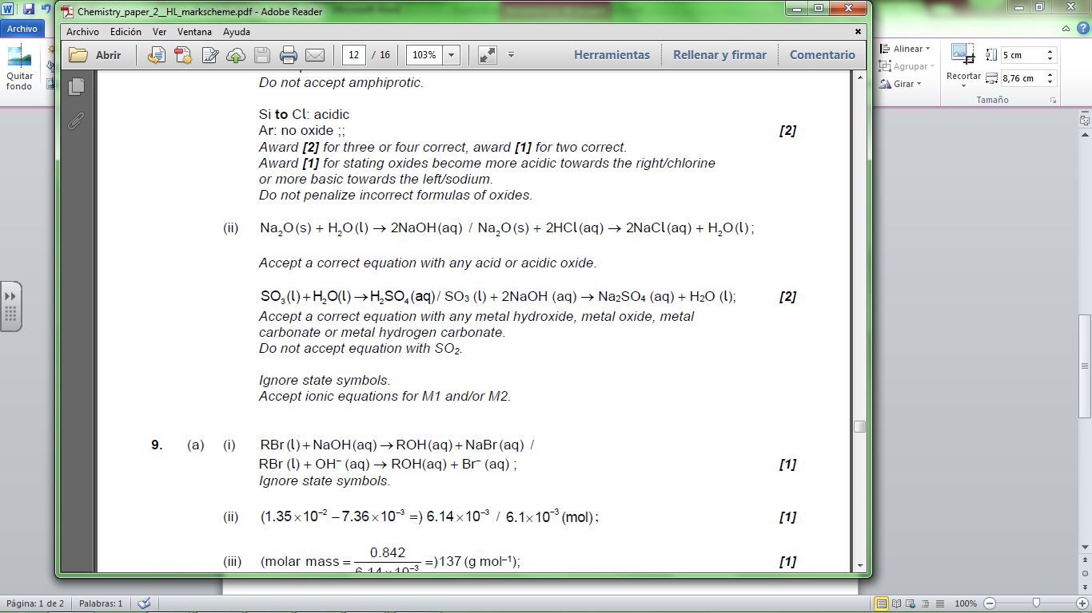

1.

**1.** (a) strong acid completely dissociated/ionized **and** weak acid partially  
dissociated/ionized;  
HNO3(aq) → H+(aq) + NO3–(aq);  
HNO2(aq)  H+(aq) + NO2–(aq);  
*Allow only arrows as shown.  
State symbols not needed.  
Accept H2O and H3O+*. 3

(b) *With HNO3*:  
faster rate of bubble/gas/hydrogen production;  
faster rate of magnesium dissolving;  
higher temperature change;  
*Accept opposite argument for HNO2.  
Award* ***[1]*** *if 2 observations given but acid is not identified.  
Reference to specific observations needed.* 2 max

(c) (i) (nitric acid) 7.5 cm3; 1

(ii) not valid as nitrous acid reacts with same volume/ 7.5 cm3; 1

(d) HNO3;  
(higher conductivity for solutions with same concentration as) there are  
more ions in solution; 2

[9]

**2.** (a) (i) strong acid completely dissociated/ionized **and** weak acid partially  
dissociated/ionized;  
HNO3(aq) → H+(aq) + NO3–(aq);  
HCN(aq)  H+(aq) + CN–(aq);  
*Insist on both arrows as shown.  
State symbols not needed.  
Accept H2O and H3O+.* 3

(ii) *K*a =   
*Allow H3O+* *instead of H+.  
K*a= 10–9.21 = 6.17 × 10–10; 2

(iii) [H+] = ;  
 = 8.16 × 10–6;  
*Allow in the range 8.13 × 10–6* *to 8.16 × 10–6.*pH = 5.09;

**OR**

pH = (p*K*a – log[HCN]) / (9.21 – log 0.108);  
 = 5.09;  
[H+] = 10–5.09 = 8.16 × 10–6;  
*Allow in the range 8.13 × 10–6* *to 8.16 × 10–6.  
If expression for [H+] missing but both answers correct, award* ***[3]****,  
if one answer correct, award* ***[2]****.*

assume [H+] << 0.108 / negligible dissociation; 4

(b) *With HNO3*:  
faster rate of bubble/hydrogen/gas production;  
faster rate of magnesium dissolving;  
higher temperature change;  
*Accept opposite argument for HCN*.  
*Reference to specific observations needed.  
Award* ***[1]*** *if 2 observations given but acid is not identified.* 2 max

(c) (i) (nitric acid) 7.5 cm3; 1

(ii) not valid as hydrocyanic acid reacts with same volume/ 7.5 cm3; 1

(iii) bromothymol blue / phenol red / phenolphthalein; 1

(d) HNO3;  
(higher conductivity for solutions with same concentration as) there are  
more ions in solution; 2

[16]

**3.** (i) HIn is a weak acid / weak base;  
 HIn  H+ + In–;  
colour 1 colour 2  
 *required*.  
*Award* ***[2]*** *for M2 alone.*

in base equilibrium moves to right / in acid equilibrium moves to left; 3

(ii) phenolphthalein;  
indicator colour change occurs in range of pH at the equivalence  
point / *OWTTE*; 2  
*M2 can be scored independently even if indicator is incorrect.*

[5]

**4.** *n*(HCl) = (0.100 × 0.50) = 0.050 (mol);  
*n*(NaOH) = (0.200 × 0.10) = 0.020 (mol);  
*n*(HCl)remaining = (0.050 – 0.020) = 0.030 (mol);  
[HCl] =  = 0.10 (mol dm–3);  
pH = 1.0; 5  
*Award* ***[2 max]*** *for just pH = 1.0 without working.*

[5]

**5.** (a) initial amount of HCl =  × 1.00 × 10–2 = 2.50 × 10–4 mol  
**and** initial amount of NH3 =  × 1.00 × 10–2 = 5.00 × 10–4 mol;  
final amount of NH4+ and NH3 both = 2.50 × 10–4 mol;  
final [NH4+] and [NH3] both =  = 3.33 × 10–3 mol dm–3;  
[OH–] = *K*b ×  = *K*b = 10–4.75 /1.78 × 10–5;  
pOH = 4.75 hence pH = 9.25; 5  
*Award final two marking points if half-equivalence method used.*

(b) a buffer solution resists a change in pH when small amounts of  
acid or base are added to it;  
*Do not accept description in terms of composition of buffer.*

when H+ is added it reacts with NH3 to form NH4+;  
when OH– is added it reacts with NH4+ to form NH3 and H2O; 3  
*Accept equations for last two marking points.*

[8]

**6.** (i) NH3 weak(er) base/partial dissociation;  
[OH–] < 0.1(0) /pOH > 1 (thus pH < 13 / pH + pOH = 14); 2

(ii) around pH = 5;  
*Accept a value between 4 and 6.*

strong acid–weak base titration, (thus acidic) / at equivalence point, NH4+  
present is acidic / NH4+  NH3 + H+; 2

(iii) NH3(aq) + H2O(l)  NH4+(aq) + OH–(aq);  
*Ignore state symbols, but equilibrium sign required.*

*K*b = ; 2

(iv) [NH3] = [NH4+]; 1

(v) pOH = 14.00 – 9.25 = 4.75;  
p*K*b (= pOH) = 4.75;  
*K*b = 1.78 × 10–5;  
*Ignore units.  
Award* ***[3]*** *for correct final answer.* 3

(vi) optimum/most effective/highest buffer capacity/50 %–50 % buffer/equally  
effective as an acidic buffer and a basic buffer / *OWTTE*; 1

[11]

**7.** (a) 2NH3(aq) + H2SO4(aq)  (NH4)2SO4(aq); 4

Accept correct equation with NH4OH instead of NH3  
n(H2SO4) = 0.0201×0.150 (mol);  
n(NH3) = 6.03×10–3 (mol);  
[NH3] = 0.241 (mol dm–3);

Award **[3]** for the correct final answer for the concentration calculation.

(b) bromocresol green;  
reaction of weak base and strong acid;  
pH range of bromocresol green is 3.8 to 5.4/occurs at pH < 7; 3

(c) (i) *K*b = 10–4.75 = 1.78×10–5;  
*K*b =   
[OH–] =   
pOH = 2.83; 4

Award **[4]** for the correct final answer.

Allow ECF, for example any correct conversion of [OH–] to pOH.

(ii) a solution which resists change in pH / changes pH very slightly;  
when small amounts of acid or base are added;  
weak acid and its salt / weak acid and its conjugate base; 3

(iii) n(NH3) = 0.00500 (mol) **and** n(HCl) = 0.00250 (mol);  
  
[OH–] = *K*b = 1.78×10–5;  
(pOH = 4.75 so) pH = 9.25 *(allow 9*.*2 to 9*.*3)*; 4

Award **[4]** for correct final answer.

Accept other valid methods.

[18]