DEPARTAMENTO DE
CIENCIAS NATURALES
Name and surname:……………………………………………………………
Calculating magnifications
FORMULAS
$$Magnification =\frac{Measured size (ruler)}{Real size (scale bar)}$$
$$Magnified size =Real size x magnification$$
$$Real size =\frac{Magnified size (ruler)}{Magnification}$$

EXAMPLE 1
To calculate the magnification used to establish the image right you need to apply the formula;
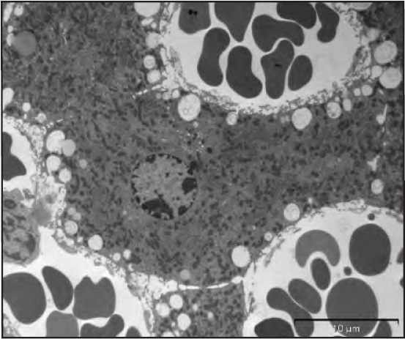
$$Magnification=\frac{Measured size (ruler)}{Real size (scale bar)}$$
The real size of the scale bar is 10 µm.
The measured size with a ruler would be 20 mm, so that you convert to µm = 20 000 µm .

$Magnification=\frac{20000}{10}$= 2000x

10 µm
EXAMPLE 2
10 µm
If you want to calculate the size of the nucleus of the liver cell you see on the image, you use the same magnification you just calculated.

Calculate real size
Step 1: convert to same unit (µm)

Step 2: apply formula

So real size: = 14 mm or 14000 µm
= 14000 µm/2000
= 7 µm

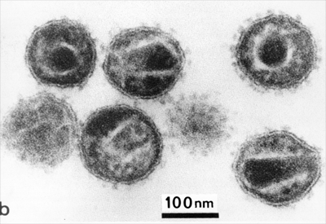
Task 1
Which is the magnification of the image of the HIV viruses here on the right?
…………………………………………………………………………………………………………………………………………………………………………………………………………………………………………………………………………………………………………………………………………………………………………………………………………………………………………
……………………………………………………
……………………………………………………

TASK 2
Follow the instructions on pg 5 of your book to make several microscopic drawings of the animal cells, plant cells and unicellular organisms prepared for you in the lab. For some you will have to prepare the slides yourself.
What is the real size of the organisms/cells? Add a scale bar to each drawing.

