- Define the following concepts:
- Period
Elements in the same row of the periodic table all have electrons in the same main energy level.
- Ionic bonding

The electrostatic attraction between oppositely charged ions.

- State which of the following substances have hydrogen bonding: CH₄, HCl, NH₃, LiH.
NH3

- Order the following substances in terms of increasing melting points: metallic, simple covalent, giant covalent.
Simple covalent, metallic, giant covalent

- (Normally formulation) Describe the 4 quantum numbers and underline which of the following are allowed: (1,0,0,1/2) (3,1,2,-1/2) (2,1,0,1/2) (4,0,-1,1/2)
n – describes the main energy level, l – describes the shape of the orbital, m – describes the specific orbital, s – describes the spin
- Describe how you could distinguish between a simple molecular covalent compound and a giant covalent (lattice) compound.
Carry out a melting point test – Simple low, Giant high

- In Rutherford’s experiment, most of the alpha particles passed through the gold foil without deflection. However, some of them showed some deflection and a few were even reflected back. Indicate, giving the reasons, how these observations leads to Rutherford’s atomic model.

Most passed through Most of the atom is empty space
Small number reflected Small, dense area of positive charge somewhere in the space

- State the full exlectron configuration for:
- N (Z=7) 1s2 2s2 2p3

- Zr (Z=40) 1s2 2s2 2p6 3s2 3p6 4s2 3d10 4p6 5s2 4d2

- Br- (Z=35) 1s2 2s2 2p6 3s2 3p6 4s2 3d10 4p6

- Explain, giving reasons, which is the most likely type of bonding found between the following chemical elements (EN = electronegativity):
- Na (EN=0.9) and Cl (EN=3.0)
Difference 2.1 Ionic

- Cu (EN=1.9) and Zn (EN=1.6)
Difference 0.3 BUT ONLY METAL ATOMS PRESENT Metallic

- State and explain the trend observed in the boiling points of the following substances (methane, ethane and pentane):

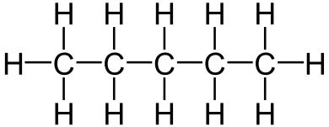
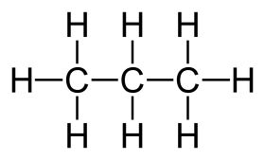
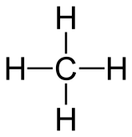

Increasing BP left to right. All these molecule have only London forces so the larger the molecule, the stronger the London forces and the higher the BP.

- State and explain how atomic volume (radius) changes down a group and across a period in the periodic table.
Down a group ionic radius increases due to increasing number of electron shells.
Across a period it decrease as electrons are all in the same shell but the number of protons is increasing. The increase in nuclear (positive) charge pulls the electrons closer to the nucleus.

- Design a method to distinguish between the four kinds of substances we have studied in the lab based in making tests of its properties.
Describe what we did in the lab!!!

- Imagine that you are Rutherford making his experiment. You observe that most alpha particles pass through the gold foil but some of them remain inside it. Propose an atomic model according to these observations and explain your reasons for it.
Again, that most of the atom is empty space but perhaps he would have also concluded that there is a small area of strong negative charge in the atom (a negative nucleus) so the positive alpha particles were attracted into it.

