- State the law that corresponds to the following graphs:

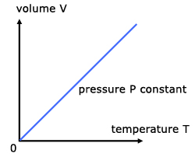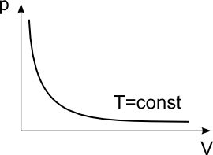

0.3 - Charles’ law 0.3 - Boyle-Mariotte’s law

- Order the following elements by increasing electronegativity: O, Li, Fe, F.
1 - Li<Fe<O<F
0.6 – 1 mistake
0.3 – 2 mistakes

- State the type of bonding between the atoms of a substance that has the following properties: low melting point, non-soluble in water but soluble in organic solvents, non-conductor.
1 - Simple covalent (molecular)
0.6 - Covalent

- Formulation

a) Barium oxide: BaO f) CH₄: methane
b) Phosphoric acid: H₃PO₄ g) HNO₂: nitrous acid
c) Ammonium chloride: NH₄Cl h) MgCrO₄: magnesium cromate
d) Tin(IV) hydroxide: Sn(OH)₄ i) MnO₂: manganese(IV) oxide
e) Cobalt(II) nitrate: Co(NO₃)₂ j) H₂S: hydrosulphuric acid

- Explain why Bohr’s model can explain the atomic spectra, but previous models cannot.
0.3 -Bohr’s model describes different energy level in an atom.
0.3 - Atomic spectra are the result of electronic jumps and drops between the different levels.
0.3 - Previous models did not include description of energy levels so no spectra could be produced.

- Using the following table, indicate, giving the reasons, two elements that would bond using ionic bonding, two elements that would use covalent bonding, and two elements that would use metallic bonding.

Element | O | S | Zn | Zr
Electronegativity | 3.5 | 2.6 | 1.6 | 1.4

0.3 - Ionic: O-Zn or O-Zr, because non-metal/metal or difference of electronegativity higher than 1.8
0.3 Covalent: S-O, because non-metal/on-metal or difference of electronegativity lower than 1.8 while individual values rather high
0.3 Metallic: Zr-Zn, Zn-Zn, Zr-Zr - because metal/metal or difference of electronegativity lower than 1.8 while individual values rather low

- Explain the changes of state on the basis of the kinetic theory.
0.3 for each:
Solid – Kinetic energy is not enough to overcome IMFs so particles in fixed positions.
Liquid – Kinetic energy enough to partially overcome IMFs so particles move freely but stay close.
Gas – Kinetic energy enough to completely overcome IMF so particles move freely.

- We have 200 cm³ of a gas, initially at 27 ºC. Calculate the final volume if we increase the temperature at 87 ºC while maintaining constant pressure.
0.3 for each:
V/T=V’/T’;
200/300=V/360;
V=240 cm³
Partial if lack of units or calculation mistake.

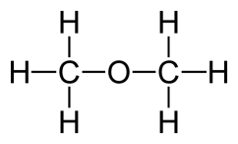
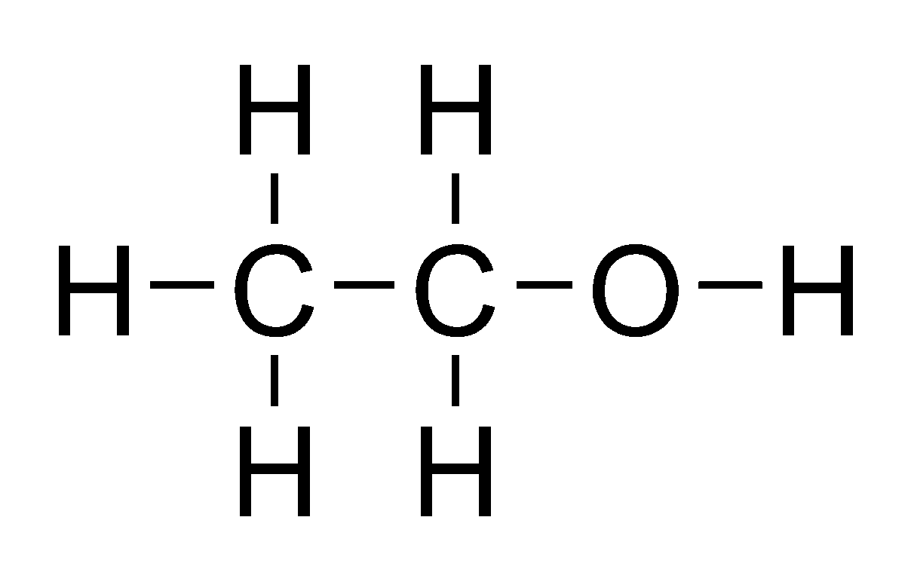
- These are the structures of ethanol and dimethyl ether, two organic compounds with exactly the same molecular formula, and so, the same molecular mass. However, ethanol´s boiling point is 78 ºC, while dimethyl ether´s is -24 ºC. Explain this fact.
Ethanol Diethyl ether

0.3 - Ethanol has hydrogen bonds, as it has oxygen bonded to hydrogen,
0.3 - While diethyl ether has not and their intermolecular forces are London forces, much weaker than hydrogen bonding.
0.3 - So, its boiling point is much lower.
Both IMFs must be mentioned to be correct. Partial if one is missed.

- Explain metallic bonding and state the properties of metallic substances.
0.3 – Sea of delocalized electrons around positive ions
0.3 for two of following – Allows conduction of electricity, conducts heat, high MP and BP

- Determine the molar mass of an unknown gas that has a volume of 4.1 L at a temperature of 27 °C, a pressure of 1.5 atm, and a mass of 11 g. Data: R=0.082 atm·L/K·mol
0.3 for each:
pV=(m/PM)RT;
PM=mRT/pV;
=44 g/mol
OR
Use PV=nRT;
Calculate n;
Use moles=mass(g)/mm
- Alkanes are compounds that contain only carbon and hydrogen atoms.
The graph to the right shows the boiling points of alkanes with different numbers of carbon atoms.
Explain this trend.
0.3 - The boiling point increases with the number of carbon atoms.
0.3 - As the number of carbon atoms increases, the molecule becomes bigger and therefore the strength of the London forces increases due to increasing number of electrons.
0.3 - As this is the only IMF present in the compound, the larger compounds will require more energy to overcome the stronger London forces. Hence a higher boiling point.

