Session 12: | TESTING A LEAF FOR STARCH

Assessed criteria
Criteria E: AIE

Background Information
Green plants absorb light energy using chlorophyll in their leaves. They use it to react carbon dioxide with water to make a sugar called glucose. The glucose is used in respiration, or converted into starch and stored. Oxygen is produced as a by-product.
This process is called photosynthesis. Temperature, carbon dioxide concentration and light intensity are factors that can limit the rate of photosynthesis.
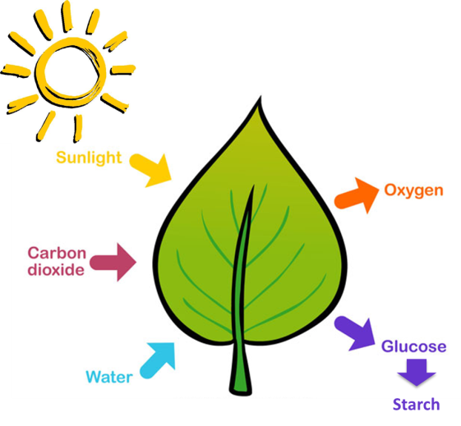

Objective
To test if photosynthesis has taken place by testing leaves for starch. We can use the iodine test to see if any starch is present.

Materials

A geranium leaf half-covered with aluminum foil two days before the experiment | 250 mL beaker | Test tube
Bunsen burner, tripod and gauze | Hot water (kettle) | 1 L beaker (labelled ‘Waste ethanol’) per table
Petri dish | Iodine in potassium iodide solution (lugol) | Ethanol
Tweezers | Glass rod | Safety glasses

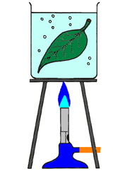
Method
- Take the half-covered leaf.
- Put on your safety glasses
- At your desk, pour about 150-200 mL of boiling water from a kettle into a 250 mL beaker. This kill the cells in the leaf and break down the membrane, allowing the iodine solution gets through cell membrane to reach starch inside the chloroplasts and react with them.
- Using tweezers, pick up the leaf and hold it in the hot water for about one minute.
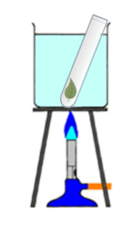
- Using tweezers, remove the leaf from the boiling water and note how it has changed.
- Fill the test tube with about 10 mL of ethanol
- Drop the leaf into the test tube and push it to the bottom with a glass rod.
- Place the test tube in the beaker containing hot water. Watch as the ethanol boils and the green colouring (chlorophyll) is removed from the leaf. This will take a few minutes.
- Replace the hot water with freshly-boiled water from the kettle after 5 minutes if there is still some green colour in the leaf.
- Using tweezers, remove the leaf from the boiling tube and rinse the leaf in cold water.
- Place the leaf on the petri dish and add some drops of iodine solution. Make sure the leaf is completely covered with iodine.
- Watch for a few minutes to see if a blue-black colour develops in any part of the leaf. A blue-black colour with iodine solution indicates that starch is present.

Results (Complete this section)
Take a picture of your leaf and insert it in here. Describe what you can see.
In the picture we can see

Conclusion (Complete this section – Write a letter to Dra. Brennan explaining what starch is, and giving her a reason why it is used for glucose storage in plants. Then explain to her why its presence in the leaves indicates that photosynthesis has taken place.

Dear Dra Brennan…

References
Nuffield Foundation. Improving social well-being through education, research and innovation. Retrieved 9 July 2015
http://www.nuffieldfoundation.org/practical-biology/testing-leaves-starch-technique

