Scatter Graphs
SUCCESS CRITERIA: Where are you now with your understanding of scatter graphs?
Learning outcomes | YES | More or less | Not yet
Can I plot points on a scatter graph?
Can I describe the relationship between the data, including correlation?
Can I draw and use a "line of best fit" to estimate results?

Plotting points on a scatter graph
Below are the marks of eight students in their Maths and Science tests. Plot the points on the scatter graph underneath.
Student | A | B | C | D | E | F | G | H
Maths mark | 56 | 73 | 51 | 62 | 24 | 67 | 94 | 35
Science mark | 62 | 68 | 45 | 68 | 35 | 73 | 88 | 32
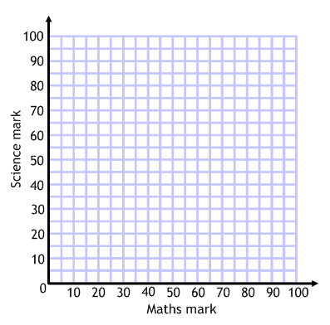
Have a go at these two scatter graphs:
The data below shows the number of scarves sold by a shop in a week and the temperature that day:
Day of the week | M | T | W | T | F | S | S
Sales of scarves | 73 | 56 | 54 | 38 | 7 | 39 | 82
Temperature (⁰C) | 9 | 13 | 15 | 19 | 25 | 12 | 5
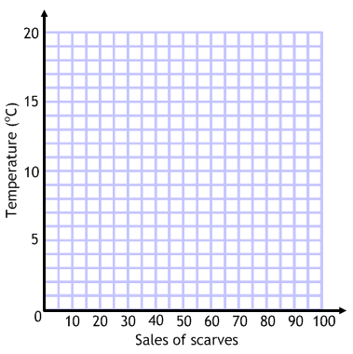
The data below shows the amount of petrol used by a car and the distance driven on eight different journeys:
Journey | 1 | 2 | 3 | 4 | 5 | 6 | 7 | 8
Distance (km) | 75 | 140 | 237 | 180 | 20 | 93 | 104 | 42
Petrol used (l) | 7 | 12.5 | 25.3 | 16 | 3.5 | 8.9 | 9.5 | 4.1
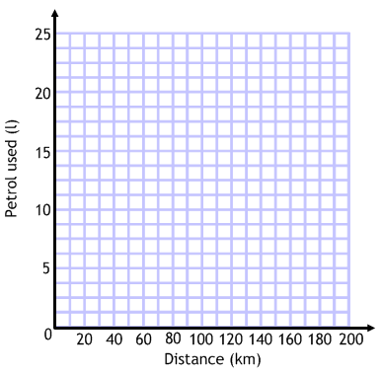
Correlation
What do you think would be the correlation of these sets of data?
- The sales of ice creams as the temperature rises during the summer.
- The value of a mobile phone as it gets older.
- The amount you'll get in a maths test the further you live from school.

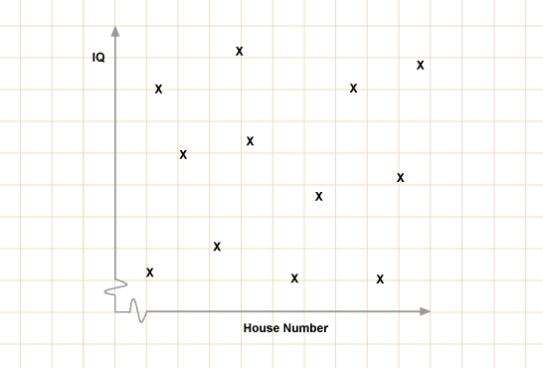 ………………………………………………
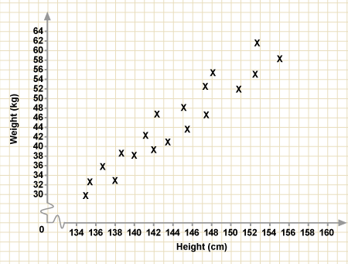 ………………………………………………
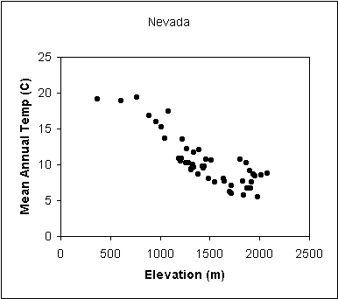 ………………………………………………

Draw the scatter graph and describe the correlation:
Below are listed some test marks for 8 students. Plot them on the scatter graph and describe the correlation.
Student | A | B | C | D | E | F | G | H
Maths mark | 56 | 73 | 51 | 62 | 24 | 67 | 94 | 35
Art mark | 54 | 43 | 47 | 44 | 82 | 31 | 18 | 87

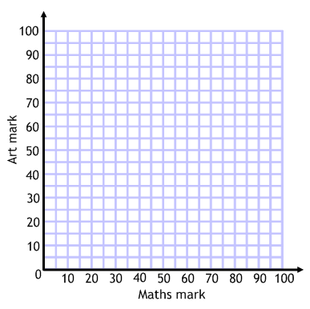

The data has ………………………………………………………………… correlation.

“Line of best fit” and estimating results
Estimate, using your graph, how many scarves the shop would sell when the temperature was 7ºC.
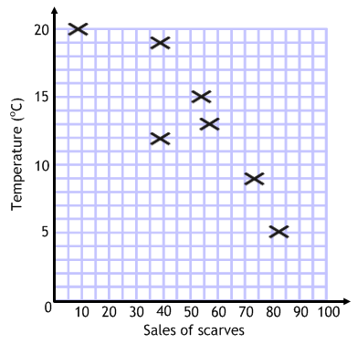

Number of scarves: ……………………………………………………
Estimate, using your graph, how many litres of petrol the car would use on a journey of 160km.

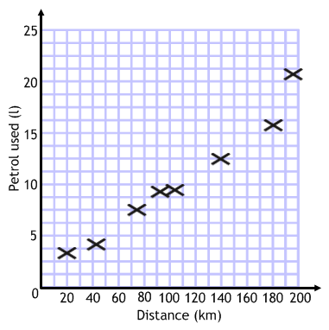

Number of scarves: ……………………………………………………

