|  |  |
| --- | --- |
| **Session 7:** | **ENERGY CONTENT OF A PEANUT** |

## 

## Assessed criteria

Criterion E: AIE

**Research Question**

“How can we determine the stored (potential) energy in a peanut?”

**Background Information**

The three main energy-providing organic molecules found in foods are **lipids**, **carbohydrates** and **proteins**. We are able to know the calorific content of food from its molecules composition. The amount of energy in food labels is often expressed in kcal/100g. The energy value varies a lot according to the type of food that we are eating. Some of the energetic values are shown below:

|  |  |
| --- | --- |
| Lard | 670 |
| Butter | 752 |
| White rice | 354 |
| Chocolate flavoured cereals | 358 |
| Breakfast cereals with honey | 386 |
| Breakfast cereals without sugar | 386 |
| Wholemeal flour | 340 |
| Refined wheat flour | 353 |
| Chickpeas | 361 |

Calories that are counted in our everyday diet are based upon the same units of heat that measure the potential energy stored within chemical bonds. As substances react, chemical bonds are broken and reformed. During this process, energy is released. The amount of released energy is measured in calories and is dependent upon the original energy content of the reactant bonds. Foods that are high in calories have chemical bonds that when rearranged give off large amounts of energy. When a high-energy bond is broken, a large amount of energy is released. If the body cannot use all of this energy, it stores the excess within the chemical bonds of fat.

There are two types of calories: scientist calories and nutritionist calories. When scientists speak of calories they are talking about the amount of heat it takes to raise the temperature of water. One calorie to a scientist is the amount of heat energy it takes to raise the temperature of 1 gram (or 1 millilitre) of water up 1 ºC. A thousand calories is called a kilocalorie (kcal) and is the amount of heat energy needed to raise a 1,000 grams (or 1 litre) of water up 1 ºC.

**1 calorie** = the amount of heat energy it takes to raise

the temperature of 1 gram of H2O by 1 ºC

**1 kilocalorie (kcal)** = 1,000 cal

**1 Food Calorie** = 1 kcal = 1,000 “little” calories

When nutritionists speak of calories or when you look up the number of calories on a food label it is actually telling you the number of kilocalories that the food contains. For this reason, when speaking of calories in food we will use an uppercase “C”. So one Calorie is equal to 1 kilocalorie which is equal to 1000 calories (lowercase "c").

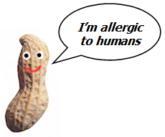

**CAUTION**: If you are allergic to peanuts inform your teacher immediately BEFORE doing this activity. If any of the peanuts you are working with are allergic to you, then also inform the teacher immediately.

**Objective**

To determine how many calories a peanut contains in kcal/g.

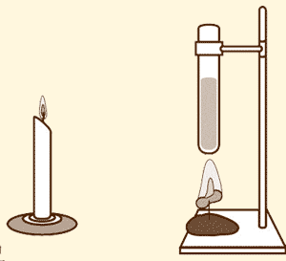**Materials**

|  |  |  |
| --- | --- | --- |
| ½ peanut | Water | Blowtorch |
| Clamp stand | Test tube | Watch glass |
| Clamps | Pipette 5 mL | Electronic scale |
| Nail | Pipette bulb | 100 mL beaker |
| Plasticine | Thermometer | Safety goggles |
|  |  |  |

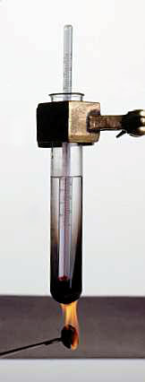**Method**

1. Weigh half of a peanut on the scale and get its initial weight (initial mass: **m0**)
2. Pin the ½ peanut to the nail.
3. Stick the nail vertically to the clamp stand using plasticine.
4. Fill the beaker with water and pipette 5 mL from it.
5. Add the 5 mL to the test tube and clamp it to the stand.
6. Place the test tube over the peanut at a distance of 5 cm.
7. With a thermometer record the initial temperature,**T0** , of the water.
8. Call your teacher and ask him/her to light the peanut.
9. Avoid any movements which may interfere with the flame while the peanut is burning!
10. Once the peanut has completely burned record the new temperature of the water (final temperature: **Tf**). **Note: Stir the water with the thermometer before taking your measurement to ensure the same temperature throughout the test tube**.
11. Weigh the peanut again on the scale (final mass: **mf**).
12. Repeat the experiment 2 more times making sure you record all the measurements.

**Results** - Complete the table – Make sure that the table has title and headings with units.

|  |  |  |  |  |  |  |  |
| --- | --- | --- | --- | --- | --- | --- | --- |
| **Trial number** | **m0 (g)** | **mf (g)** | **m0  - mf (g)** | **T0 (ºC)** | **Tf (ºC )** | **Tf  - T0**  **(ºC )** | **Energy content (J/g)** |
| **1** |  |  |  |  |  |  |  |
| **2** |  |  |  |  |  |  |  |
| **3** |  |  |  |  |  |  |  |
| **Other student results** | | | | | | | |
| **1** |  |  |  |  |  |  |  |
| **2** |  |  |  |  |  |  |  |
| **3** |  |  |  |  |  |  |  |
| **Other student results** | | | | | | | |
| **1** |  |  |  |  |  |  |  |
| **2** |  |  |  |  |  |  |  |
| **3** |  |  |  |  |  |  |  |
| **Average** |  |  |  |  |  |  |  |

**Calculate the average energy value of the peanut in J/g .**

1. Calculate the rise in temperature each time.
2. Calculate the energy released from each food by using this formula.

How Much Energy Is There In Food Equasion

* + 4.2 is the value of the specific heat capacity of water, in joules per gram per degree Celsius – the number of joules taken to raise the temperature of water by 1 °C. 1 cm3 of water has a mass of 1 g.
  + If the number is more than 1000 J/g, express it as kilojoules (kJ):
  + 1 kilojoule = 1000 joules
  + Find the value for the energy content of a peanut in the bibliography. Include the reference for the last one.

One calorie is equal to 4,19J. Convert your result to Calories and calculate the error between your result and the values in the books using the following formula:

% error = (Value from books - Experimental value) x 100/Value from books

**Calculations: (**include your calculations).

**Conclusion** (*Complete this section*)

Draw conclusions from your results and link to scientific reason.

**Evaluation** (*Complete this section*)

Identify errors and indicate possible sources. Give any suggestions on how to decrease these errors.

**References** (*Complete this section*)