BOYLE-MARIOTTE’S LAW

Task

To explain the relationship between pressure and volume (at constant n and T) using kinetic theory.

Materials
A manometer
A syringe
Thermometer
Barometer

Method/Procedure
In this experiment a constant mass of gas, at constant temperature, will be used. The volume of air contained in a syringe will be modified in order to observe how the pressure of the system subsequently varies.

- Write down the room temperature and atmospheric pressure at the moment of the experiment (Use the thermometer and barometer hanging on the laboratory wall). Pay special attention to the units!!!
- Set the piston at the highest position so that the volume contained is the maximum.
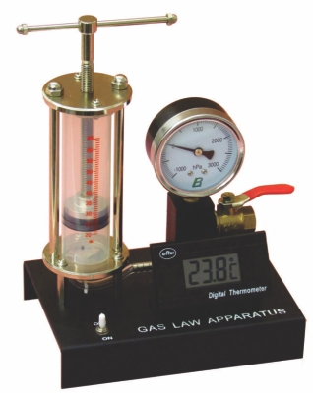

- Read the pressure in the manometer located at the tip of the syringe.

- Read and write down the pressure measurements shown by the manometer as the volume of gas contained inside the syringe is varied. Then, calculate the total pressure exerted on the internal gas.

- Once finished with the experimental data (no less than 10 valid measurements), organise your results in a table where new columns for the product P·V and the inverse volumes (1/V) should be included.

- Draw two graphs, one showing P versus V and another plotting P versus 1/V.

Questions (for conclusion)
Identify the independent, dependent and controlled variables in this experiment.
Why do we have to keep temperature constant?

How do you express in the form of a mathematical equation that two magnitudes are “inversely proportional”?

Why do we have a difference between the barometer and manometer?

Questions (for evaluation)
How could we improve the experiment or the results?
How can we make sure our results are correct?

