|  |  |
| --- | --- |
| SFP_logo_esp  DEPARTAMENTO DE  CIENCIAS | Summative Activity  Science Yr 8  3rd Term |
| Name and surname | |
| Date \_\_\_\_\_\_\_\_\_\_\_\_\_\_\_\_\_\_\_\_ Mark \_\_\_\_\_\_\_\_\_ D\_\_\_\_\_. E\_\_\_\_. | |

**Criterion B: Inquiring and designing**

|  |  |  |  |
| --- | --- | --- | --- |
| **Achievement level** |  |  | **Level descriptor** |
| **0** | The student does not reach the standard described in any of the levels below. | | |
| **1-2** | The student is able to:  i. **state** a problem or question to be tested by a scientific investigation  ii. **outline** a testable hypothesis  iii. **outline** the variables  iv. **design** a method, with limited success |  | ☐ The **research question** or problem is inappropriate or incorrectly formulated.  ☐ The **research question** or problem is **stated** using minimal scientific vocabulary not based on research.  ☐ The **hypothesis** is **formulated** but not **described** and **not** theoretically **justified.**  ☐ **Variables** are not correctly **identified** as independent, dependent and controlled.  ☐ The **manipulation and measuring** of all the variables has barely been **described** and mistakes are often made.  ☐ The method does not allow for the **collection of sufficient relevant data**.  ☐ **The method** is not **clear** or **safe** and not well **structured**.  ☐ An incomplete **list of materials**, and without **proper names**, is included.  ☐ No references have been included. |
| **3-4** | The student is able to:  i. **outline** a problem or question to be tested by a scientific investigation  ii. **formulate** a testable hypothesis using scientific reasoning  iii. **outline** how to manipulate the variables, and outline how relevant data will be collected  iv. **design** a safe method in which he or she selects materials and equipment |  | ☐ The **research question** or problem is **formulated** but it is not concise.  ☐ The **research question** or problem is **outlined** using the proper scientific vocabulary and based on some research.  ☐ The **hypothesis** is **formulated** and **described** but **not** theoretically **justified.**  ☐ Independent and dependent **variables** are correctly **identified** but controlled variables are incomplete.  ☐ The **manipulation and measuring** of all the variables is **described**, but with some important mistakes.  ☐ The method barely allows for the **collection of sufficient and relevant data**.  ☐ **The method** is not always **clear** or **safe** and could be better **structured**.  ☐ An incomplete **list of materials**, and not always with **proper names**, is included.  ☐ A **reference list** is included but not in the APA format or with some mistakes. |
| **5-6** | The student is able to:  i. **describe** a problem or question to be tested by a scientific investigation  ii. **formulate** and **explain** a testable hypothesis using scientific reasoning  iii. **describe** how to manipulate the variables, and describe how sufficient, relevant data will be collected  iv. **design** a complete and safe method in which he or she selects appropriate materials and equipment |  | ☐ The **research question** or problem is adequately **formulated**, but could be more clear and concise.  ☐ The **research question** or problem is **described** using the proper scientific vocabulary and based on some research.  ☐ The **hypothesis** is **formulated**, **explained** and theoretically **justified** but with **limited** **scientific reasoning**.  ☐ **Variables** are correctly **identified** as independent, dependent and controlled.  ☐ The **manipulation and measuring** of all the variables is **explained** with little mistakes.  ☐ The method allows for the **collection of sufficient and relevant data**.  ☐ The **method** is **clear**, **safe** and **logically structured**, with little mistakes.  ☐ A complete **list of materials, mostly** with their **proper names**, is included.  ☐ A **reference list** is included in the APA format. |
| **7-8** | The student is able to:  i. **explain** a problem or question to be tested by a scientific investigation  ii. **formulate** and **explain** a testable hypothesis using correct scientific reasoning  iii. **explain** how to manipulate the variables, and explain how sufficient, relevant data will be collected  iv. **design** a logical, complete and safe method in which he or she selects appropriate materials and equipment. |  | ☐ The **research question** or problem is well formulated, clear and concise.  ☐ The **research question** or problem is well explained using the proper scientific vocabulary and based on previous research.  ☐ The **hypothesis** is well formulated, explained and theoretically justified with correct scientific reasoning and without mistakes.  ☐ **Variables** are correctly identified as independent, dependent and controlled.  ☐ The **manipulation and measuring** of all the variables is **well explained**.  ☐ The method allows for the **collections of sufficient and relevant data**.  ☐ The **method** is completely clear, safe and logically structured.  ☐ A complete **list of materials**, with their **proper names**, is included.  ☐ A **reference list** is included in the **APA format**. |

**Task:** To plan an investigation on how friction affects the motion of an object sliding on a surface.

A **force** is a push or a pull, exerted by one object onto another.

**Friction** is the force that opposes the motion of one material sliding past another.

It is easy to deduce some characteristics about the force of friction: it depends on the flatness of the surfaces touching each other as well as the mass of the object. Friction always makes objects slow down…… until they come to a stop.

There are many possible experiments to test the force of friction, such as the following examples:

1. You can let objects slide (not roll) on an inclined plane.
2. You can look at how much you must incline a slope for an object to start moving.
3. You can measure the force applied to start an object moving on a flat surface.

or others you can find on the internet.

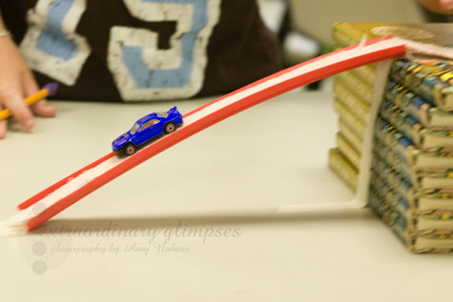

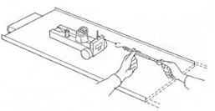

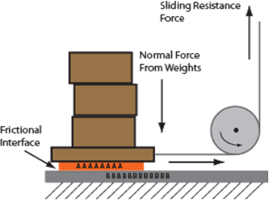

After you have done some research on the web about friction choose a factor you think affects it, establish your hypothesis and design an experiment to investigate this.

**Note**: For this formative assessment you will need to complete the following sections of a lab report:

1. The research question
2. Background information
3. The hypothesis (supported by some background information)
4. The independent, dependent and control variables
5. **Materials and method** (step by step, 3rd person imperative) clearly indicating how you will manipulate or measure the different variables. (**Remember to include any hazards and how you can keep the investigation safe).**
6. **References** In APA style ([LINK](http://www.citethisforme.com))

[Click here to download the template](http://www.sciencesfp.com/uploads/2/1/5/9/21597828/format_lab_report_myp_2015.docx)

**NOTE: Sufficient data means: 3 repetitions of 5 varieties of the independent variable**

**The deadline for the formative assessment is:**

**Wednesday, April 10th/ Friday April 12th 2019.**

You will carry out this investigation in the lab and your summative lab report for Criterion B and Criterion C will be due a week after you have finished collecting data. More information will be given during the investigation weeks.

Below there is a template that includes all of the required sections for the formative proposal. Make sure you use the rubric above to check you have fulfilled the criterion, and use the checklist below to make sure you have addressed all the required points.

**Criterion B checklist:**

**Objective/Hypothesis**

□ I define an objective that relates the dependent variable to the independent one in a logical way.

□ I state a hypothesis on how the result of the experiment will be.

□ I explain my hypothesis using scientific reasoning.

**Variables**

□ I identify the independent variable, the one I change.

□ I identify the dependent variable, whose variation I record during the experiment.

□ (Only when applicable) ***If*** any of the chosen variables is not given directly by an apparatus, I explain how I relate it to the actual measurements I take.

□ I identify the controlled variables kept constant during the experiment.

**Materials/Method**

□ I make a list of materials for the experiment.

□ I suggest a method to obtain the data.

□ I can obtain a complete series of data from the experiment (at least 15?? (3x5 valid data), relating the changes of the independent variable to the variation of the dependent variable.