Session 3: | DENSITY OF SEA WATER II

Assessed criteria

Criteria C: Processing and Evaluating

Criteria E: AIE

Research Question

“Can you accurately identify samples of sea-water?”

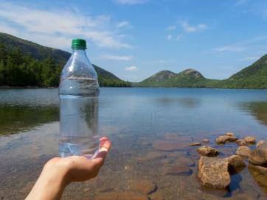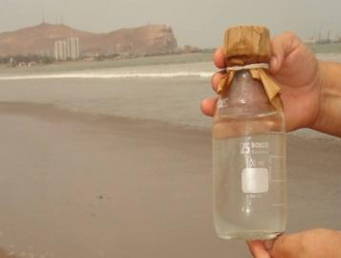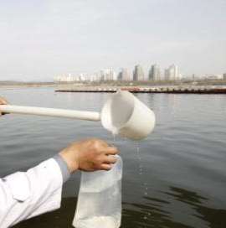

Background Information
In the previous session you produced a graph that showed the relationship between the density and concentration of salt solutions. You will now use that graph to calculate the salt concentration of four samples, in order to identify where on the planet they were collected.

If you measure the density of an unknown solution, you can draw a line on your graph to see where it intersects with the line you produced last session. Working backwards in this way will allow you to estimate the concentration of salt in the sea-water. The more accurate your graph, the more accurate your results will be.

Objective
With the data from the previous experiment, work out the concentration of unknown salt solutions that your teacher will give you. Use that information and research on the internet to suggest the location where each sample was taken.

Materials
Four samples of sea water
4x 250 mL measuring cylinder
Densimeters

Results

Table

Sample | Density (---) | Concentration (---) | Possible location (---)
A
B
C
D

(Write your results here – Make sure that it has title and headings with units)

Graph

(Insert your previous graph here, and include the intersected points– Make sure that it has title, labelled axes with units, data points and lines of best fit for each of the three lines)

Conclusion (Complete this section –Compare your results to what you stated in your hypothesis and explain how the method used has allowed you to find out an answer to your research question. Discuss your results, what concentrations did you find and where did they correlate to? Is this a reliable method to analyse samples such as these?)

Evaluation (Complete this section – Look again at the method you have used over the last two sessions, are there any stages that may have changed the accuracy of your results? Are there any changes you would make to the method if you were to perform this task again?).

References

Add your references from the conclusion here.

