Session 2: | Flame tests

Assessed criteria
Criterion E: AIE

Research Question
“How do the different chemical elements affect the colour of a flame?”

(The Huffington Post, 2015)

Objective
- To identify hazards in the laboratory and work safely around them.
- To help Mr Smith choose suitable chemical elements to make fireworks for his wife´s birthday. He wants to make sure he has 1 firework for each of her favourite colours – green, red, orange and pink.

Background Information
Mr Smith is planning a surprise fireworks show for his wife´s birthday. He knows that different chemical elements can sometimes have different coloured flames because he studied natural science at school.

To make the fireworks, Mr Smith needs to choose suitable chemical elements to put in each one. He wants to make fireworks that match his wife´s favourite colours.

Materials
- Lithium, sodium and potassium metal (teacher demonstration)
- Water trough, chopping board and knife (teacher demonstration)
- Salts of copper, lithium, sodium, potassium, barium and calcium
- Bunsen burner
- Wooden splints and nichrome wire
- Acid (0.5 M HCl)
- 100 mL beaker
- Safety goggles
Safety (Complete this section)
This lab session has 3 hazards that we must consider to be able to carry out the experiment safely. Complete the table below to show you can work safely in the lab.

Chemical/equipment | Hazard symbol | What do you think hazard symbol means? | What will you do to reduce the risk of injury?
Acid | 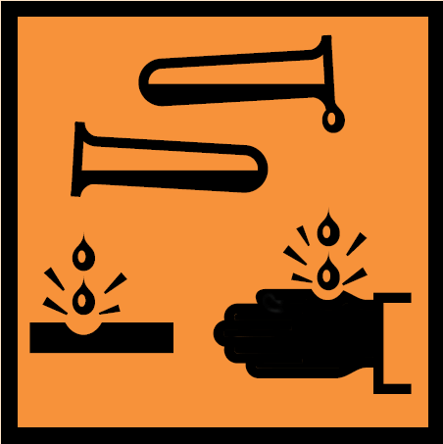
Copper chemical | 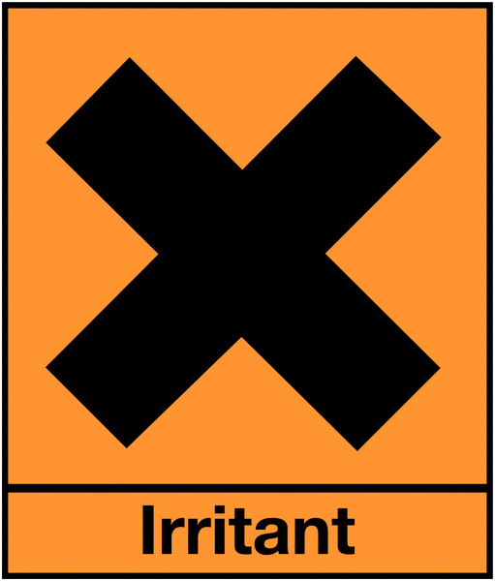
Bunsen burner | No symbol | ---------- | Wear safety goggles and tie up long hair

Method
- Make a flame testing stick using the wooden splint and nichrome wire.
- Use the acid to clean the end of the wire.
- Dip the end of the wire in one of the chemicals and hold it in the Bunsen burner flame.
- Record the colour in the table below.
- Clear the wire in the acid and repeat the process for each substance.

Results (Complete this section)

Table1- Table to show the colour of flames of different chemical elements

Chemical element | Chemical symbol | Colour of flame
Sodium
Lithium
Potassium
Copper
Calcium
Barium

Conclusion (Complete this section – Write a letter to Mr Smith explaining which chemical elements he should use in his fireworks)

Dear Mr Smith…

References
The Huffington Post,. (2015). Best Hotels For Watching Fourth Of July Fireworks. Retrieved 7 July 2015, from http://www.huffingtonpost.com/hipmunk/best-hotels-for-watching_b_5535198.html

