Using a Schlenk tube
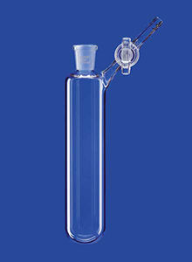

Objective
To prepare a tutorial on the preparation of a Schlenk tube”.

Theoretical background
Schlenk tubes are used most frequently when investigating gases as we will see in Unit 3.

Blog tasks
The whole report must be posted to your group blog. Make sure you include:
- A description of the uses of a Schlenk tube.
- Photos showing the individual pieces of equipment and their names.
- A video with subtitles showing the full preparation.
- A written procedure.

